**“Data Hiding Using Steganography”**

Industrial Oriented Mini Project/Internship/Skill Development Course (Big data-Spark) /Societal Related Project

Bachelor of technology in

COMPUTER SCIENCE AND ENGINEERING

By

**M. Kalyani - 22631A0519**

**SK. Azra - 22631A0506**

**S. Lalitha Shivapriya - 22631A0523**

**MD. Nazeema Begum - 22631A0527**

**T. Ujwala Sri - 22631A0556**

**P. Yagneshwar - 22631A0562**

Under the Esteemed guidance of **Mr. P. Rathaiah** Sr. Asst. Prof. in CSE Department



**DEPARTMENT OF COMPUTER SCIENCE AND ENGINEERING**

**SRI VENKATESWARA ENGINEERING COLLEGE**

(SPONSERED BY THE EXHIBITION SOCIETY, HYD)

(Affiliated to Jawaharlal Nehru Technological University, Hyderabad) SURYAPET,

SURYAPET (DIST), PIN: 508213, Telangana, India

June-2025

**SRI VENKATESWARA ENGINEERING COLLEGE**

**DEPARTMENT OF COMPUTER SCIENCE AND ENGINEERING**

**SURYAPET-508213**



**CERTIFICATE**

This is to certify the project entitled “**Data Hiding Using Steganography**” is the bonafide work done by

M. Kalyani - 22631A0519

SK. Azra - 22631A0506

S. Lalitha ShivaPriya - 22631A0523

MD. Nazeema Begum - 22631A0527

T. Ujwala Sri - 22631A0556

P. Yagneshwar - 22631A0562

in partial fulfilment of the requirements for the award of ***Bachelor of Technology in Computer Science and Engineering*** by **JNTUH** during the academic year 2024-2025.

**Head of the Department Guide**

Mr. P. Rathaiah B.Tech, M.Tech Mr. P. Rathaiah B.Tech, M.Tech

Sr. Asst. Professor Sr. Asst. Professor

Depart. Of CSE Depart. Of CSE

Sri Venkateshwara Engineering College, Sri Venkateshwara Engineering College,

Suryapet. Suryapet.

**Principal** **External Examiner** Dr. Raju Muthyala M. Tech, PhD

Sri Venkateshwara Engineering College, Suryapet.

**DECLARATION**

We, *M. Kalyani, SK. Azra, S. Lalitha Shivapriya, MD. Nazeema Begum, T. Ujwala Sri, P. Yagneshwar* students of BTech with Computer Science and Engineering of Sri Venkateshwara Engineering college, Suryapet, being H.T. No 22631A0519, 22631A0506, 22631A0523, 22631A0527, 22631A0556, 22631A0562, respectively, hereby declare that the project with title “***Data Hiding Using Steganography***” is the original work done by us.

To the best of our knowledge and belief, we hereby declare that this project bears no resemblance to any other project submitted at Sri Venkateswara Engineering College, Suryapet or any other college affiliated to Jawaharlal Nehru Technological University, Hyderabad for the award of the degree.

Place: **Suryapet**

Date: /06/2025

***Signature of the candidate***

M. Kalyani

SK. Azra

S. Lalitha ShivaPriya

MD. Nazeema Begum

T. Ujwalasri

P. Yagneshwar

**ACKNOWLEDGEMENT**

We express our profound gratitude to the Almighty for granting us the courage and perseverance to complete this project. This project stands as a testament to the contributions and support of many individuals who have played a vital role in its success.

We extend our heartfelt thanks to ***Mr. P. Rathaiah***, Head of the Department of Computer Science and Engineering, ***Dr. M. Raju***, Principal for providing excellent facilities, motivation, and encouragement, which were instrumental in the timely completion of this project.

We would also like to express our deep sense of gratitude to our parents for their moral support and heartfelt cooperation throughout the duration of this project. Additionally, we are grateful to all the teaching and non-teaching staff, as well as our friends, whose direct or indirect assistance has been invaluable in the successful completion of this work.

***Project Associate***

M. Kalyani

SK. Azra

S. Lalitha ShivaPriya

MD. Nazeema Begum

T. Ujwalasri

P. Yagneshwar

***Abstract***

Steganography is the practice of hiding information within another medium in a way that conceals the very existence of the hidden content. In the digital age, image files are commonly used as cover media to embed secret data such as text, files, or other images. Unlike cryptography, which secures the content of a message, steganography hides its existence, making it an effective tool for secure communication.

This project focuses on image-based steganography, where confidential data is embedded within images without perceptible changes to the human eye. With the rise of digital communication, the need for discreet data transfer methods has increased. By integrating steganography with robust algorithms, this project aims to enhance security against unauthorized access, detection, and potential attacks.

**Hardware Requirements:**

**Processor:** Intel core i5 (Minimum dual-core processor required)

**RAM:**16GB (Minimum 4GB or higher for better experience)

**Storage:**150GB Hard Disk Space (Minimum 60GB required)

**Development Tools:** Visual Studio

**Software Requirements:**

**Operating System:** Windows

**Code Editor:** VS Code

**Front end:** HTML5, CSS3

**Backend:** Python, frameworks used flask, OpenCV

**Head of the Department**  **Co-Ordinator** & **Guide**

Mr. P. Rathaiah Sr. Asst. B.Tech, M.Tech Mr. P. Rathaiah Sr. Asst. B.Tec h, M.Tech

**Table of Contents**

|  |  |
| --- | --- |
| **Contents** | **Page** |
| CERTIFICATE | ii |
| DECLARATION | iii |
| ACKNOWLEDGEMENT | Iv |
| ABSTRACT | v |
| ABBREVATIONS / GLOSSARY | 1 |
| CHAPTER 1 INTRODUCTION | 4 |
| PROJECT AIMS AND OBJECTIVES | 4 |
| BACKGROUND OF PROJECT | 5 |
| CHAPTER 2 LITERATURE SURVEY | 7 |
| CHAPTER 3 FEASIBILITY STUDY | 11 |
| CHAPTER 4 SYSTEM ANALYSIS | 13 |
| CHAPTER 4.1 EXISTING SYSTEM | 13 |
| CHAPTER 4.2 PROPOSED SYSTEM | 15 |
| CHAPTER 5 SYSTEM STUDY | 15 |
| CHAPTER 5.1.1 HARDWARE REQUIREMENTS | 16 |
| CHAPTER 5.1.2 SOFTWARE REQUIREMENTS | 16 |
| CHAPTER 5.2 LIBRARIES USED | 16 |
| CHAPTER 5.3 DATA FLOW | 17 |
| CHAPTER 5.4 REQUREMENT ANALYSIS | 17 |
| CHAPTER 5.4.1 FUNCTIONAL REQUIREMENTS | 18 |
| CHAPTER **5.4.2** NON-FUNCTIONAL REQUIREMENTS | 18 |
| CHAPTER 6 SYSTEM IMPLEMENTATION | 21 |
| CHAPTER 6.1 MODULES | 31 |
| CHAPTER 6.2 SAMPLE CODE | 32 |
| CHAPTER 7 UML DIAGRAMS AND DATABASE ANALYSIS | 38 |
| CHAPTER 7.1 UML DIAGRAM | 41 |
| CHAPTER 8 SYSTEM TESTING | 59 |
| CHAPTER 9 CONCLUSION AND FUTURE SCOPE OF PROJECT | 65 |
| CHAPTER 10 SYSTEM SECURITY | 67 |
| CHAPTER 11 REFERENCES | 69 |
| VOTE OF THANKS | 70 |

**ABBREVATIONS / GLOSSARY**

1. Python & Flask-Related Abbreviations

Abbreviation Full Form/Meaning

Flask Micro web framework for Python

PIL/Pillow Python Imaging Library (for image processing)

np NumPy (used for array operations)

BytesIO In-memory binary stream (from io module)

base64 Encoding binary data to ASCII characters

UUID Universally Unique Identifier (for image IDs)

ORM Object-Relational Mapping (not used directly, but MySQL connector works similarly)

HTTP Hypertext Transfer Protocol (GET/POST requests)

CRUD Create, Read, Update, Delete (database operations)

2. Cryptography & Steganography Terms

Term Meaning

LSB (Least Significant Bit) Hiding data in the least noticeable bits of pixel values

Caesar Cipher A substitution cipher that shifts letters by a fixed number

Steganography Concealing messages within other files (e.g., images)

Null Terminator (chr(0)) Marks the end of an embedded message

Base64 Encoding Converts binary image data to a text string for HTML display

Shift Key (shift=3) Number of positions to shift letters in Caesar cipher

3. Database & Storage Terms

Term Meaning

MySQL Relational database for storing image metadata

image_id Unique identifier (UUID) for each encrypted image

encrypted_images In-memory dictionary storing temporary image data

cursor Database cursor for executing SQL queries

db.commit() Saves changes to the database

4. Image Processing Terms

Term Meaning

RGB Red-Green-Blue color mode (used for pixel manipulation)

Pixel Array (np.array(img)) Converts image to a NumPy array for bit manipulation

Flattened Array (flat_data) 1D representation of image pixels for LSB embedding

8-bit Binary (format(ord(char), '08b')) Converts a character to 8-bit binary (e.g., 'A' → '01000001')

5. Security Terms

Term Meaning

Password Authentication Verifies users before decryption

YOU ARE NOT AUTHORIZED! Error message for incorrect passwords

In-Memory Storage Temporary storage (avoids saving encrypted images to disk)

6. Key Functions & Variables

Symbol/Function Purpose

caesar_cipher_encrypt() Encrypts text with Caesar cipher

caesar_cipher_decrypt() Decrypts Caesar cipher text

encrypt_message() Embeds encrypted text into an image (LSB)

decrypt_message() Extracts and decrypts hidden message

image_stream Input image file stream

binary_message Message converted to binary for LSB insertion

img_io BytesIO object holding the encrypted image

7. HTTP Routes

Route Purpose

/ Homepage (index.html)

/encrypt Handles image encryption (GET/POST)

/decrypt Handles image decryption (GET/POST)

/download/<image_id> Downloads encrypted image

8. Error Messages

Message Cause

"Message cannot be empty." No text provided for encryption

"Message too long for the image." Image too small for the message

"Image ID not found." Invalid UUID during decryption

"MySQL Error: ..." Database connection/query failure

**CHAPTER 1**

**INTRODUCTION**

In today's digital age, protecting sensitive information is more crucial than ever. Our project, Image Steganography with Password Protection, offers a secure and user-friendly solution to embed confidential messages within image files using a combination of steganography and password-based access control.

This web-based application, built using Flask, OpenCV, and HTML/CSS, enables users to:

* Encrypt messages by hiding them inside images.
* Decrypt messages only when the correct password is provided.
* Download the encrypted image securely.

With an elegant and intuitive glassmorphism-style frontend, users can seamlessly interact with the system to hide or reveal secrets in a visually engaging way. By integrating password protection, the tool ensures that even if an encrypted image is intercepted, its hidden message cannot be accessed without proper authentication.

This project highlights the fusion of image processing and cybersecurity concepts, demonstrating a practical approach to secure communication.

**Project Aim:**

The aim of this project is to develop a secure, user-friendly web application that enables users to hide and retrieve confidential messages within digital images using steganography, enhanced with password protection for added security.

**Objectives:**

1. **Implement Image Steganography:**  
   Embed secret textual information into image files using pixel-level manipulation without significantly altering the image quality.
2. **Ensure Password Protection:**  
   Introduce a password mechanism to restrict unauthorized access during the decryption process, enhancing security.
3. **Develop a User-Friendly Interface:**  
   Design an intuitive and visually appealing frontend using HTML, CSS (with glassmorphism), and responsive layout techniques.
4. **Enable Secure Image Upload and Download:**  
   Allow users to upload their own images, encrypt messages into them, and download the resulting encrypted images safely.
5. **Incorporate Error Handling:**  
   Provide meaningful error messages for cases like incorrect password entry, unsupported file types, and oversized messages.
6. **Maintain File Management:**  
   Manage image uploads and encrypted outputs effectively within a secure directory structure on the server side.
7. **Demonstrate Real-World Use of Steganography:**  
   Highlight how image steganography can be applied in fields like data privacy, secure communication, and digital watermarking.

**BACKGROUND OF PROJECT**

The **steganography project** is aimed at developing a system for securely embedding secret messages or data into a cover medium, such as an image, in a way that the hidden content remains undetectable to the human eye. Steganography, a technique for concealing information, has been used for centuries to ensure the secrecy and integrity of sensitive data during transmission. Unlike encryption, which transforms data into an unreadable format, steganography hides the data in a way that doesn't attract attention, making it an ideal method for covert communication.

This project leverages the concept of **Least Significant Bit (LSB) steganography**, a common technique for embedding secret messages into images. By modifying the least significant bits of the pixel values in an image, the data can be concealed without significantly altering the image's appearance. The project allows users to upload an image (cover image), enter a secret message, and optionally provide a password to encrypt the message for added security. The system then processes these inputs and generates a stego-image, which appears identical to the original image but contains the hidden message.

The project also involves creating a user-friendly inteearface, where users can easily upload images, enter messages, and securely encrypt their data. The encrypted message is embedded into the image, ensuring that only users with the correct decryption key can retrieve the original information. The system may also support the option of uploading files instead of plain text messages, enhancing its versatility.

Overall, the steganography project emphasizes the importance of privacy and security, offering an easy-to-use tool for securely hiding information in images. This approach can be applied in a wide range of fields, such as secure communication, digital watermarking, and data protection.

**CHAPTER 2**

**LITERATURE SURVEY**

**Abstract**

Steganography is the art and science of concealing secret data within a cover medium (such as images, audio, video, or text) to prevent unauthorized detection. Unlike cryptography, which focuses on securing data through encryption, steganography ensures that the existence of the message remains hidden. This survey provides a detailed analysis of various steganography techniques, classifying them into spatial domain, transform domain, spread spectrum, model-based, and hybrid methods. Each technique is evaluated based on imperceptibility, robustness, and embedding capacity. Additionally, performance metrics such as Peak Signal-to-Noise Ratio (PSNR), Mean Square Error (MSE), and Correlation Coefficient (CR) are discussed to assess the effectiveness of different approaches. The study concludes with a comparative analysis, highlighting the strengths and weaknesses of each method, and suggests future research directions, including AI-based adaptive steganography for enhanced security.

**1. Introduction to Steganography**

Steganography plays a crucial role in secure communication by hiding sensitive information within digital media. The primary goal is to ensure that the presence of the embedded data remains undetectable while maintaining the integrity of the cover medium. Three key factors define an effective steganographic system:

* Imperceptibility: The hidden data should not introduce noticeable distortions in the cover medium.
* Robustness: The embedded information should withstand common attacks such as compression, noise, and filtering.
* Capacity: The amount of data that can be embedded without degrading the quality of the cover medium.

This paper systematically reviews different steganography techniques, categorizing them based on their embedding domains and analyzing their performance.

**2. Classification of Steganography Techniques**

**2.1 Spatial Domain Techniques**

Spatial domain methods directly modify pixel values in the cover image to embed secret data. These techniques are computationally efficient but often lack robustness against attacks.

Least Significant Bit (LSB) Steganography replaces the least significant bits of pixel values with secret data. While simple and capable of high embedding capacity, LSB is vulnerable to statistical attacks and noise. It is commonly used in applications where security is not a critical concern.

Pixel Value Differencing (PVD) embeds data based on the difference between adjacent pixels. This method offers better imperceptibility than LSB, particularly in edge regions where pixel variations are higher. However, it remains susceptible to histogram analysis attacks.

Quantization Index Modulation (QIM) uses quantization techniques to embed data without interfering with the host signal. QIM provides good robustness against noise and controlled embedding capacity but is more complex than LSB.

Multiple Base Notational System (MBNS) converts secret data into symbols using variable bases before embedding. This approach enhances payload capacity and improves Peak Signal-to-Noise Ratio (PSNR) compared to PVD. However, it lacks robustness against aggressive attacks.

**2.2 Transform Domain Techniques**

Transform domain techniques embed data in the frequency domain, making them more robust against compression and noise.

Discrete Cosine Transform (DCT) embeds data in the middle-frequency coefficients of the transformed image. DCT is highly resistant to JPEG compression but suffers from block artifacts and cropping vulnerabilities.

Discrete Wavelet Transform (DWT) decomposes the image into sub-bands (LL, LH, HL, HH) for embedding. DWT provides multi-resolution embedding and better imperceptibility but requires higher computational resources.

Singular Value Decomposition (SVD) embeds data in the singular values of the image matrix. SVD is highly robust against noise and geometric attacks but may introduce diagonal artifacts in the extracted watermark.

**2.3 Spread Spectrum Steganography**

This technique spreads secret data across multiple frequencies, making it resistant to statistical attacks. While highly secure, spread spectrum steganography is complex to implement and is primarily used in military and defense applications.

**2.4 Model-Based Steganography**

Model-based techniques use statistical models to embed data without altering the cover medium’s properties. These methods provide high security and adaptive embedding but are computationally intensive.

**2.5 Hybrid Techniques**

Hybrid methods combine multiple steganography techniques (e.g., DWT-SVD, DCT-DWT) to enhance robustness and imperceptibility. While they offer superior performance, their complexity increases significantly.

**3. Performance Metrics**

The effectiveness of steganography techniques is evaluated using the following metrics:

Peak Signal-to-Noise Ratio (PSNR) measures the quality of the stego-image, with higher values indicating better imperceptibility.

Mean Square Error (MSE) quantifies the distortion between the original and stego-image, where lower values signify better quality.

Correlation Coefficient (CR) assesses the similarity between the original and extracted watermark, with values closer to 1 indicating higher accuracy.

**4. Comparative Analysis**

A comparative study reveals that spatial domain techniques (e.g., LSB, PVD) are simple and offer high embedding capacity but lack robustness. Transform domain methods (e.g., DCT, DWT, SVD) provide better resistance to attacks but require more computational power. Hybrid techniques deliver the best security and performance but are the most complex.

|  |  |  |  |  |
| --- | --- | --- | --- | --- |
| Technique | Robustness | Capacity | Complexity | Best Use Case |
| LSB | Low | High | Low | Basic hiding |
| PVD | Moderate | Moderate | Moderate | Edge-based hiding |
| DCT | High | Low | Moderate | JPEG compression |
| DWT | High | Moderate | High | Multi-resolution |
| SVD | Very High | Low | High | Robust watermarking |
| Hybrid (DWT-SVD) | Very High | Moderate | Very High | Secure applications |

**5. Conclusion and Future Directions**

This survey highlights the strengths and limitations of various steganography techniques. While spatial domain methods are suitable for simple applications, transform domain and hybrid techniques provide better security for critical applications. Future research should explore AI-driven adaptive steganography to further enhance robustness and imperceptibility.

References

* Fkirin, A., Attiya, G., & El-Sayed, A. (2016). *Steganography Literature Survey, Classification and Comparative Study*. CAE, 5(10).

**CHAPTER 3**

**Feasibility Study**

A feasibility study is an assessment of the practicality and viability of a proposed project, system, or solution. It aims to determine whether the proposed endeavour is technically feasible, economically viable, and operationally practical. Feasibility studies are conducted before undertaking a project to evaluate its potential for success and to help stakeholders make informed decisions about whether to proceed with the proposed initiative.

**TECHNICAL FEASIBILITY:**

The proposed Image Steganography project is technically feasible with the available tools, technologies, and expertise. The application is developed using the Python programming language, leveraging the Flask web framework for the backend to handle routing, file uploads, and rendering templates. For image processing, OpenCV is used to read, modify, and write images at the pixel level, making it suitable for embedding and extracting hidden messages.

The system runs efficiently on standard hardware configurations without requiring high computational power or memory, making it suitable for deployment on local machines or cloud-based platforms. The HTML, CSS, and inline JavaScript provide an interactive, user-friendly frontend with a visually appealing glassmorphism UI for better user experience.

Password protection is implemented using basic file handling, making it easy to verify user credentials while decrypting. The storage requirements are minimal, and the image and password files are stored in a well-organized directory structure.

Overall, all technologies used in this project are open-source, well-documented, and compatible with each other, ensuring the project can be successfully developed, deployed, and maintained without major technical barriers.

**BEHAVIORAL FEASIBILITY:**

Behavioral feasibility assesses how well the proposed Image Steganography system will be accepted by users and how it aligns with user expectations and habits. Given the increasing concern for data privacy and secure communication, users are becoming more aware of the need for tools that allow confidential message exchange. This project provides a simple yet effective solution to that need by hiding sensitive messages within images using password protection.

The system is designed with a user-friendly interface, making it accessible even to non-technical users. The clean layout, intuitive navigation, and clear instructions reduce the learning curve significantly. Users can easily upload images, input their messages and passwords, and download the encrypted image with minimal effort.

Moreover, the decryption process is straightforward and requires only the encrypted image and the correct password, ensuring a smooth user experience. The application offers a sense of security and control, which positively influences user trust and acceptance.

Based on these factors, it is anticipated that users will be comfortable with and receptive to the system, making the project behaviourally feasible for both casual and secure communication use cases.

**OPERATIONAL FEASIBILITY:**

Operational feasibility evaluates whether the Image Steganography system can function effectively within the existing environment and meet user requirements on a daily basis. This project has been developed with simplicity, usability, and efficiency in mind, ensuring that it can operate smoothly in real-world scenarios without requiring complex resources or infrastructure.

The system is built using **Flask (Python web framework)** along with **OpenCV** for image processing, both of which are lightweight and compatible with most modern operating systems. The web-based interface allows users

to access the application through any standard web browser, eliminating the need for platform-specific installations or configurations.

Furthermore, the system supports basic file handling and uses secure password protection mechanisms for message confidentiality. All core features—such as uploading an image, encrypting or decrypting a message, and downloading the final image—work seamlessly and require only minimal hardware capabilities, such as a computer or mobile device with internet access.

The ease of use and low resource consumption ensures that the system can be successfully integrated into regular use with minimal training or technical support. Therefore, the project is **operationally feasible** and can be deployed for personal, educational, or professional use without significant operational challenges.

**CHAPTER 4**

**SYSTEM ANALYSIS**

System analysis focuses on several key activities which are typically carried out to understand, define, and document the requirements and functionalities of a system. It*s* primary goal is to identify problems, inefficiencies, or areas for improvement within the system. System analysis is a structured approach to understanding and solving complex problems within an organization or technical environment. It involves collaboration with stakeholders, thorough investigation, and careful planning to ensure the successful development and implementation of systems.

**3.1 Existing system of Data Hiding :**

Data hiding is a well-established technique used to conceal information within various forms of media, such as text, images, audio, or video. Traditional systems for data hiding primarily include cryptography and steganography. Cryptography focuses on transforming the message into an unreadable format using encryption algorithms, ensuring confidentiality even if intercepted. However, the presence of encrypted data itself may raise suspicion. On the other hand, steganography hides the very existence of the message by embedding it within cover media, such as an image, thereby offering a more discreet method of communication.

In existing image-based steganographic systems, techniques such as Least Significant Bit (LSB) substitution are commonly used, where the bits of the secret message are embedded in the least significant bits of pixel values. While effective, many traditional tools lack user-friendly interfaces, password protection, or flexibility for general users. Additionally, many existing systems are either overly complex for non-technical users or do not offer real-time feedback or download options after encryption.

These limitations paved the way for the development of a more user-friendly, web-based image steganography tool—like the one developed in this project—that combines simplicity, security, and accessibility.

**3.2 Proposed System of Data Hiding :**

The proposed system is a user-friendly, web-based image steganography application that allows users to securely hide secret messages within images using password protection. Built using Python with the Flask framework and OpenCV for image processing, the system enables users to upload an image, input a secret message and password, and receive an encrypted image in return. This image embeds the message directly into its pixel values using a modified form of Least Significant Bit (LSB) technique, making the hidden data imperceptible to the human eye.

What sets this system apart is its **intuitive interface**, **password-protected encryption**, and **immediate download access**, ensuring both security and ease of use. The decryption process requires the correct password, adding an extra layer of authentication and safeguarding the message from unauthorized access. By incorporating glassmorphism-inspired UI design, the application also provides a visually appealing user experience. Overall, the proposed system enhances the traditional data hiding mechanism by combining aesthetics, usability, and security in a single platform suitable for both technical and non-technical users.

**CHAPTER 5**

**SYSTEM DESIGN**

**4.1 SYSTEM REQUIREMENTS**

**4.1.1 HARDWARE REQUIREMENTS:**

* **Processor**- Intel core i5(Minimum dual- core processor required)
* **RAM**- 16GB (Minimum 4GB or higher for better experience)
* **Storage**- 150GB Hard Disk Space (Minimum 100GB required)

**4.1.2 SOFTWARE REQUIREMENTS:**

* **Operating System:** Windows
* **Code Editor:** VS Code
* **Front end:** HTML5, CSS3
* **Backend:** Python, frameworks used flask, OpenCV
* **Development Tools:** Visual Studio

**4.2 Libraries Used (with Versions):**

1. Flask – 2.2.5  
   Used to build the backend web framework, handle routing, rendering HTML templates, and managing form data.
2. OpenCV (cv2) – 4.7.0  
   Used for image processing tasks such as reading, modifying, and saving images with hidden messages.
3. os – *(Standard Python Library)*  
   Handles file path operations, directory creation, and other operating system-level tasks.
4. Jinja2 – 3.1.2 *(comes bundled with Flask)*  
   Template engine used for rendering dynamic content in HTML.
5. Werkzeug – 2.2.5 *(also bundled with Flask)*  
   Provides WSGI utility functions and helps handle secure file uploads

**4.3 Data flow:** 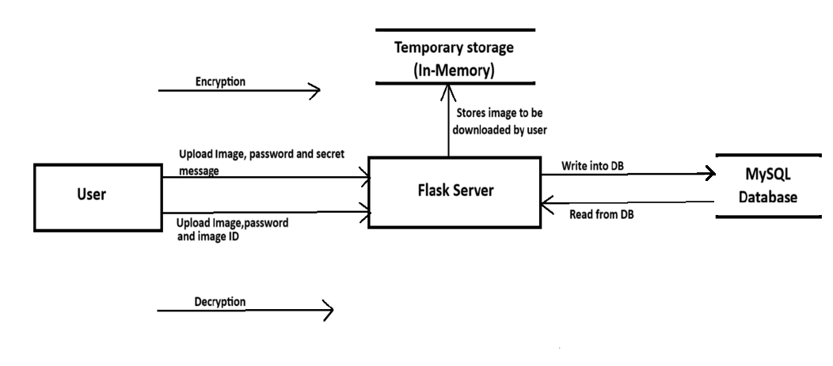

**4.4 REQUREMENT ANALYSIS**

**4.4.1 FUNCTIONAL REQUIREMENTS**

1. User Authentication & Authorization

* The system must allow users to register and log in securely.
* Only authenticated users can access the data hiding and extraction modules.

2. Input Media Upload

* The system must allow users to upload cover media (image/audio/video) to hide data.
* The system must validate media file formats (e.g., .png, .jpg, .wav).

3. Data Embedding

* The system must allow users to input a secret message or file to hide.
* The system must embed the data into the media file using a steganographic algorithm (e.g., LSB, DCT).
* The system must display a success/failure message after embedding.

4. Data Extraction

* The system must allow users to upload a stego file and extract the hidden data.
* The system must validate the file and check for hidden content before extraction.
* Extracted content must be displayed or downloaded.

5. Encryption Support (Optional Layer)

* The system should optionally allow encryption of the secret message before embedding.
* The system must require a key/password to decrypt during extraction.

6. Download & Save

* Users must be able to download the stego file after embedding.
* Extracted data must be downloadable in its original format.

7. Algorithm Selection

* The system should allow users to select the steganographic method (e.g., LSB, DCT, Spread Spectrum).

8. Integrity & Verification

* The system should perform integrity checks to ensure that data was correctly embedded and can be retrieved.
* The system should notify users if tampering or corruption is detected.

9. Responsiveness & UX

* The UI must be mobile-responsive.
* The system should display real-time progress during embedding/extraction.

10. Error Handling & Logs

* The system must provide clear error messages for unsupported files or failed operations.
* A log system should store actions like data embedding, extraction attempts, and login activity.

**4.4.2 NON-FUNCTIONAL REQUIREMENTS**

**1.Performance**

* Embedding and extraction should complete within 5 seconds for files under 5MB.
* The system should handle concurrent user operations efficiently.

**2.Security**

* User credentials and data must be encrypted.
* Secret data should not be exposed during transmission or processing.

**3.Accuracy**

* Extracted data must exactly match the original hidden content.
* Stego media must remain indistinguishable from the original to human perception.

**4.Usability**

* The interface should be user-friendly and easy to navigate.
* Instructions and feedback should be clearly provided for each step.

**5.Compatibility**

* Compatible with all modern browsers (e.g., Chrome, Firefox, Edge).
* Should function correctly on desktop, tablet, and mobile devices.

**6.Maintainability**

* Code should be modular and well-documented for easy updates.
* Errors and actions should be logged for diagnostics and debugging.

**7.Scalability**

* Should allow future integration of new steganography algorithms and file formats.
* Backend should scale to accommodate increased user load.

**8.Reliability**

* System uptime should be at least 99.9%.
* Users should be able to retry failed operations without data loss.

**System Architecture**

Based on your Flask-based steganography application, here is a clear explanation of its system architecture:

🧱 System Architecture of the Steganography Web Application

This project follows a modular, layered web application architecture built with Python (Flask), MySQL, and image processing libraries (PIL, NumPy). The architecture is composed of the following core components

1. 👩‍💻 Client Interface (Frontend):

* The user interacts through HTML forms rendered by Jinja templates (index.html, encrypt.html, decrypt.html).
* Users can upload an image, input a secret message and a password for encryption, or upload an encrypted image with the image ID and password for decryption.

2. 🌐 Web Server (Flask Application):

* Acts as the controller and entry point.
* Handles HTTP routes:
  + / → homepage
  + /encrypt → form to upload image/message/password and start encryption
  + /decrypt → form to upload image/password/image_id for decryption
  + /download/<image_id> → returns the encrypted image for download
* Communicates between user input, image handling, encryption/decryption logic, and the database.

3. 🔐 Encryption & Decryption Engine:

* Uses two algorithms:
  + Caesar Cipher (for basic message encryption and decryption)
  + LSB (Least Significant Bit) Steganography (for embedding encrypted text into image pixels)
* encrypt_message(image_stream, message):
  + Encrypts the message using Caesar cipher.
  + Converts it into binary and embeds it into the image’s LSB using NumPy.
* decrypt_message(image_bytes, password, image_id):
  + Extracts LSB bits, reconstructs the encrypted message, and decrypts it using Caesar cipher.

4. 🗄️ Storage Layer:

* In-memory Python dictionary (encrypted_images) temporarily holds encrypted images during the session.
* MySQL database (image_encryption):
  + Table image_data stores the image_id, image_name, and associated password.
  + Provides persistent password validation during decryption.

5. 📦 File Management:

* Uses BytesIO streams for temporary image storage in memory (no physical disk writes needed for encrypted images).
* Uses Base64 encoding to preview the encrypted image in the browser.

6. 🔄 Flow Summary:

* Encryption Flow:
  + User uploads image/message/password → Flask calls encrypt logic → Encrypted image generated → Password saved to DB → Image stored in memory → Response includes download link and preview.
* Decryption Flow:
  + User uploads encrypted image, provides password & image ID → Flask verifies password from DB → Message is extracted and decrypted → Plain text message shown to user.

💡 Optional Extensions:

* You could replace Caesar cipher with AES or RSA for stronger encryption.
* Passwords should ideally be hashed before saving (not in plain text).
* Encrypted image data could be stored in the database for persistent storage.

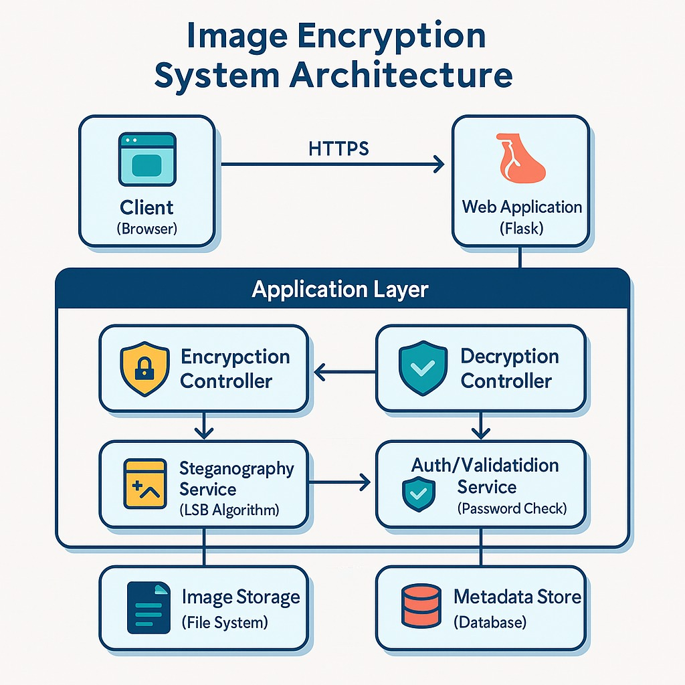

**CHAPTER 6**

**SYSTEM IMPLEMENTATION**

**Main Page:**

The home page of the Steganography-Based Data Hiding System provides users with an overview of the system's purpose and easy access to its core features like data embedding and extraction. It includes a navigation menu, login/register options, and quick action buttons. Depending on user status, it shows personalized greetings or authentication forms. The page may offer drag-and-drop file upload, display notifications, and include a footer with contact info and policy links. It is designed to be clean, user-friendly, and informative for smooth navigation.

Now first let us navigate to encryption page to perform encryption.

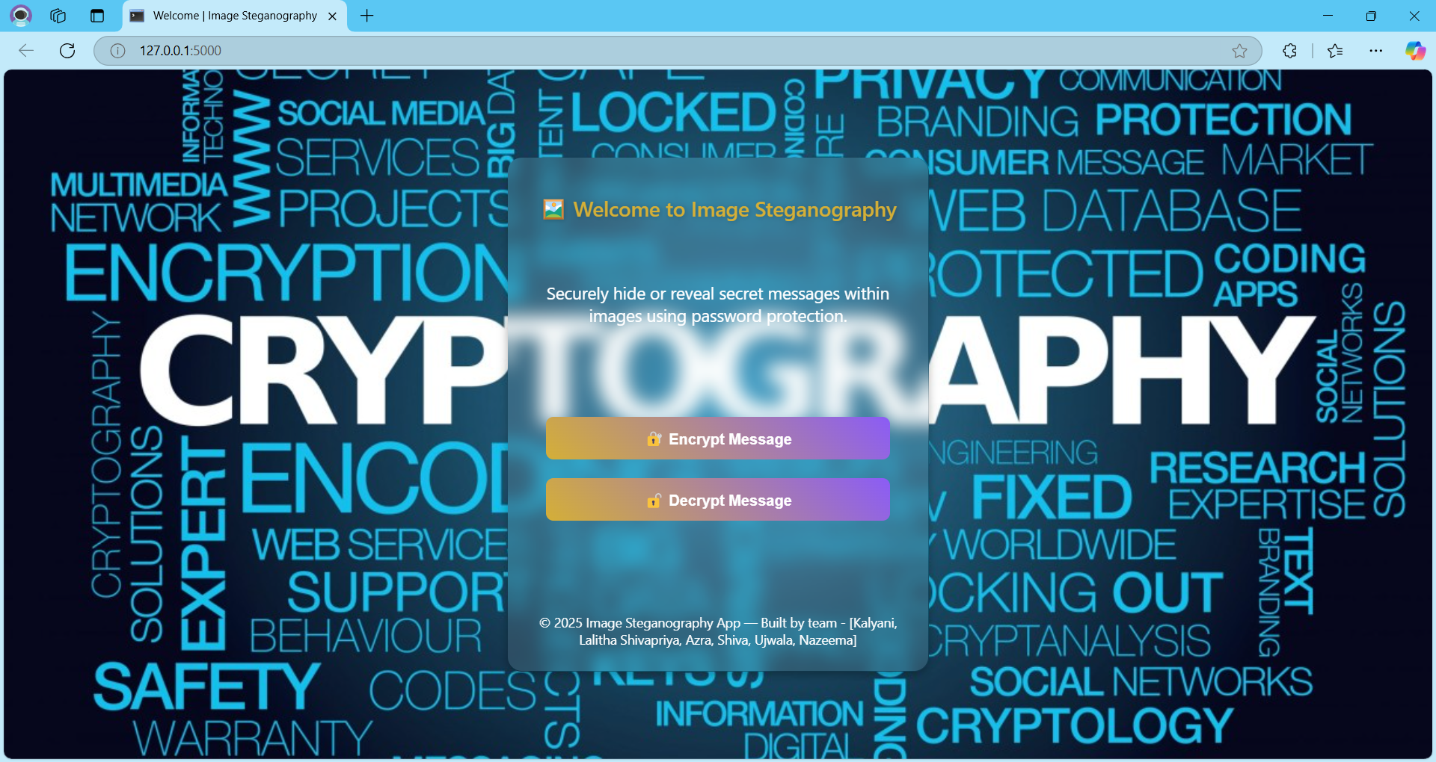

From this main page we can navigate to both encryption as well as decryption page.That means it acts as main navigator between both pages.

**Encryption:**

The Encryption Page is a crucial component of the steganography project, designed to allow users to securely embed confidential messages or files within a digital image using advanced encoding techniques. The primary purpose of this page is to take ordinary images—referred to as *cover images*—and hide secret information inside them in such a way that the resulting image, known as the *stego-image*, looks visually identical to the original, thereby preventing unauthorized access or detection.

The process begins when the user uploads a cover image through the user interface. This image acts as the medium for concealing the data. The page supports common image formats such as .png, .jpg, or .jpeg. After selecting the image, the user is prompted to enter a secret message they wish to hide. In some implementations, the user may also be allowed to upload small files (e.g., .txt, .pdf) instead of or along with a text message. For added security, the user may optionally provide an encryption key or password. If provided, this key is used to encrypt the message before hiding it, ensuring that even if the message is somehow extracted without permission, it remains unreadable without the key.

Once the message is entered, the system processes the data by converting it into a binary format. It then uses a technique like Least Significant Bit (LSB) steganography to embed the binary data into the pixel values of the cover image. This method alters the least significant bits of the image’s pixel values, which results in virtually no visible change to the image, making the stego-image indistinguishable from the original to the human eye.

After the encoding process is complete, the encrypted and data-embedded image is generated and made available for download. This stego-image can then be sent or stored safely, with the embedded data retrievable only through the corresponding decryption mechanism. The page may also include a preview feature for the user to compare the original and stego-images.

The user interface of the Encryption Page is designed to be simple, responsive, and visually appealing. If glassmorphism is implemented, the layout includes frosted-glass-like backgrounds with semi-transparent cards, glowing borders, and smooth shadows, providing a modern and elegant appearance. The page typically features components such as image upload fields, message input boxes, optional key fields, action buttons like “Encrypt” and “Download Stego Image,” and notifications or error messages for a smooth user experience.

In essence, the Encryption Page empowers users to securely hide sensitive data in plain sight, leveraging the power of steganography in a practical, visually discreet, and user-friendly manner.

**Before Encryption**

To encrypt the message on the Encryption Page, the user must first provide an image in the "Choose Image" field, a message in the "Message" field, and a password that will be required for decryption. The page presents a clean and intuitive interface for securely embedding secret messages within an image. The user is prompted to upload a cover image, which will serve as the carrier for the hidden data. Supported formats include .png, .jpg, or .jpeg, and once the image is uploaded, a preview may be displayed to ensure the correct file has been selected.

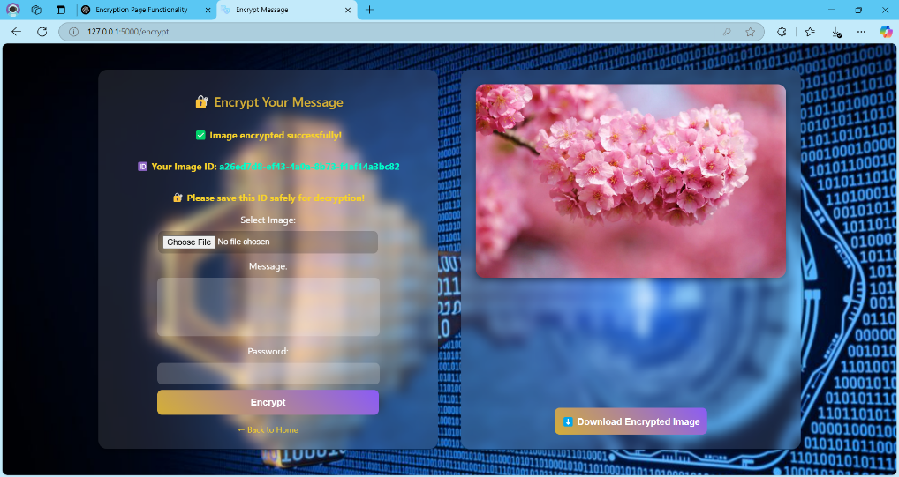

The user is then asked to input the secret message they wish to hide within the image. For additional security, they can optionally provide an encryption key or password, which will encrypt the message before embedding it, ensuring that the message remains protected. Some versions of the page may allow uploading a small file instead of plain text. As the user inputs their data, the interface performs real-time validation to check for errors, such as missing fields or unsupported formats. Once all required inputs are provided, the user clicks the clearly labeled **Encrypt** button to initiate the encryption process, preparing all components for secure steganographic encoding.

After clicking on the download encrypt image button, the image that have been encrypted will be downloaded.

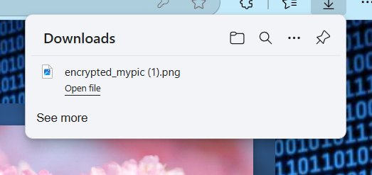

**Decryption Page:**

**Before Decryption:**

Before the decryption process begins on the Decryption Page, the user is guided through a straightforward interface designed to extract hidden information from a stego-image. The first step requires the user to upload the stego-image—the image that contains the secret message previously embedded during the encryption phase. This image is expected to look like a regular image, but it secretly holds encoded data within its pixel values. After the image is uploaded, it is usually previewed on the page to confirm that the correct file has been selected. If the original message was encrypted using a password or key, the user is prompted to enter that decryption key into a secure input field. This ensures that only users who know the correct key can unlock and retrieve the hidden message.

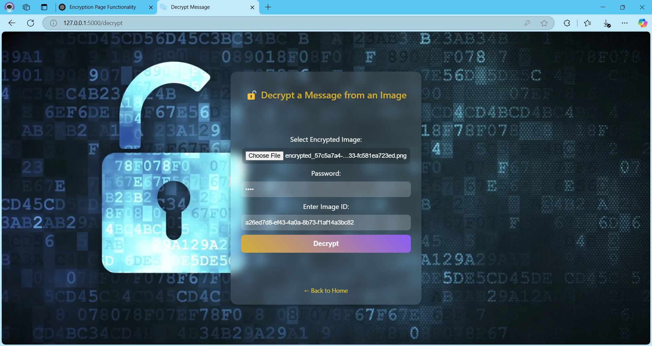

At this stage, the user interface focuses on collecting just the necessary inputs—stego-image and key (if required)—and preparing for the decoding process. A “Decrypt” button is available to trigger the extraction, and any errors such as missing files, incorrect formats, or an empty key field (if required) are handled with user-friendly validation messages. Until this point, the page acts as a setup area, waiting for the user to initiate the decryption operation.

**After Decryption:**

Once the user clicks the “Decrypt” button, the Decryption Page processes the uploaded stego-image and attempts to extract the hidden data embedded within it. If an encryption key was used during the original encryption phase, the system uses the provided key to decrypt the hidden message. The decoding algorithm carefully reads the pixel values—typically using the Least Significant Bit (LSB) technique—and reconstructs the original binary message bit by bit. After successful extraction and decryption, the hidden message is displayed on the page in a readable format, typically in a text area or message box. If the hidden data was a file, a download link may be provided instead.

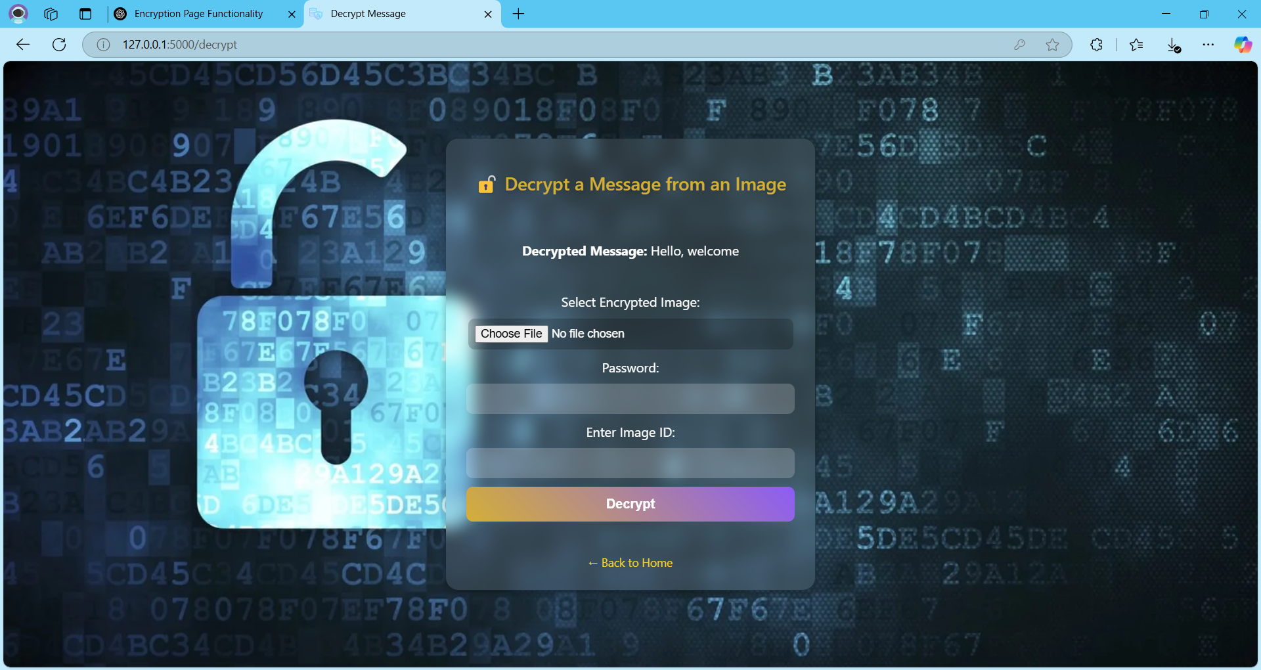

Along with the output, a success message is usually shown to inform the user that the decryption was completed successfully. If the entered key is incorrect or if the image contains no hidden data, the page displays appropriate error messages such as “Incorrect Key” or “No hidden message found.” The interface may also provide additional information, such as how many characters were extracted or the time taken to decrypt. At this point, users are given options to clear the session, save the message, or decrypt another image. The page transitions from being an input-oriented form to a results-driven display, completing the decryption cycle with clarity, security, and ease of use.

After completion of encryption or decryption if we want to go back to the main page we can click on back to home button.

**MODULES:**

A module is a self-contained unit of code that encapsulates related functionality, data structures, and dependencies. Below is a structured definition of the Image Encryption/Decryption Module from the Flask project, adhering to software engineering best practices.

**1. Database Module**

This module handles all interactions with the MySQL database.

* **Configuration:** Establishes the connection using mysql.connector with host, user, password, and database details.
* **Operations:** Executes SQL queries to store and retrieve image metadata (e.g., image_id, filename, password).
* **Security:** Verifies passwords during decryption to ensure only authorized users can extract hidden messages.

**2. Encryption/Decryption Module**

Implements **LSB steganography** to hide and retrieve messages within images.

* **Encryption (**encrypt_message**):**
  + Converts the secret message into binary.
  + Modifies the least significant bits of the image pixels to embed the message.
  + Uses a null terminator (chr(0)) to mark the end of the message.
* **Decryption (**decrypt_message**):**
  + Extracts the LSBs from the image pixels.
  + Reconstructs the original message from binary.
  + Validates the user's password against the database before revealing the message.

**3. Image Management Module**

Manages temporary storage and retrieval of encrypted images.

* **In-Memory Storage:** Uses a dictionary (encrypted_images) to cache encrypted images with unique IDs.
* **Stream Handling:** Employs BytesIO to process images without saving them to disk.
* **Base64 Encoding:** Converts images for display in HTML templates.
* **Download Functionality:** Provides a route (/download/<image_id>) to fetch encrypted images.

**4. Web Interface Module**

Controls the Flask application's routes and user interactions.

* **Routes:**
  + /encrypt – Accepts image uploads, messages, and passwords; returns encrypted images.
  + /decrypt – Validates credentials and extracts hidden messages.
  + / – Renders the homepage (index.html).
* **Templates:** Uses Jinja2 to dynamically render HTML pages (encrypt.html, decrypt.html).
* **Error Handling:** Displays user-friendly messages for invalid inputs or failed operations.

**5. Utility Module**

Provides supporting functions for security and data processing.

* **UUID Generation:** Creates unique identifiers for each encrypted image.
* **Input Validation:** Checks for empty messages or missing fields.
* **Binary Conversion:** Transforms text messages into binary strings and vice versa.

**6. Security Module (Implicit)**

Ensures secure access and data integrity.

* **Password Protection:** Requires a password for both encryption and decryption.
* **Authorization:** Compares user-provided passwords with database records.
* **Error Handling:** Returns "NOT AUTHORIZED" messages for incorrect credentials.

**Data Flow Overview**

1. **Encryption Path:**  
   User upload → LSB encryption → Metadata stored in MySQL → Image cached in memory → Download link generated.
2. **Decryption Path:**  
   User upload → Password verification → LSB extraction → Message displayed (if authorized).

This modular design ensures separation of concerns, making the system scalable and maintainable. Each component can be updated independently (e.g., swapping LSB for AES encryption) without disrupting the overall workflow.

**Sample code:**

from flask import Flask, render_template, request, send_file, url_for

import os

import mysql.connector

import uuid

from PIL import Image

import numpy as np

from io import BytesIO

import base64

app = Flask(__name__)

# MySQL configuration

db = mysql.connector.connect(

    host="localhost",

    user="root",

    password="sharvan8",

    database="image_encryption"

)

cursor = db.cursor()

# In-memory storage for encrypted images

encrypted_images = {}

# LSB Encryption

def encrypt_message(image_stream, message):

    try:

        # Validate message

        if not message or len(message.strip()) == 0:

            return None, None, "Error: Message cannot be empty."

        img = Image.open(image_stream).convert('RGB')

        data = np.array(img)

        flat_data = data.flatten()

        message += chr(0)  # Null terminator

        binary_message = ''.join([format(ord(char), '08b') for char in message])

        if len(binary_message) > len(flat_data):

            return None, None, "Error: Message too long for the image."

        for i in range(len(binary_message)):

            flat_data[i] = (flat_data[i] & 0b11111110) | int(binary_message[i])

        encrypted_data = flat_data.reshape(data.shape)

        encrypted_image = Image.fromarray(encrypted_data.astype('uint8'), 'RGB')

        img_io = BytesIO()

        encrypted_image.save(img_io, 'PNG')

        img_io.seek(0)

        base64_encoded_image = base64.b64encode(img_io.getvalue()).decode('utf-8')

        return img_io, base64_encoded_image, None

    except Exception as e:

        return None, None, f"Encryption Error: {str(e)}"

# LSB Decryption

def decrypt_message(image_bytes, entered_password, image_id):

    try:

        cursor.execute("SELECT password FROM image_data WHERE image_id = %s", (image_id,))

        result = cursor.fetchone()

        if not result:

            return "Error: Image ID not found."

        stored_password = result[0]

        if entered_password != stored_password:

            return "YOU ARE NOT AUTHORIZED!"

        image_stream = BytesIO(image_bytes)

        img = Image.open(image_stream).convert('RGB')

        data = np.array(img).flatten()

        bits = [str(pixel & 1) for pixel in data]

        chars = [chr(int(''.join(bits[i:i+8]), 2)) for i in range(0, len(bits), 8)]

        message = ''

        for c in chars:

            if c == chr(0):  # Null terminator

                break

            message += c

        return message

    except Exception as e:

        return f"Decryption Error: {str(e)}"

@app.route('/')

def index():

    return render_template('index.html')

@app.route('/encrypt', methods=['GET', 'POST'])

def encrypt():

    if request.method == 'POST':

        image = request.files.get('image')

        message = request.form.get('message')

        password = request.form.get('password')

        if not image or not message or not password:

            return render_template('encrypt.html', error="All fields are required.")

        encrypted_io, base64_image, error = encrypt_message(image.stream, message)

        if error:

            return render_template('encrypt.html', error=error)

        try:

            image_id = str(uuid.uuid4())

            filename = image.filename

            # Store encrypted image in memory

            encrypted_images[image_id] = {

                'filename': filename,

                'data': encrypted_io

            }

            # Save to MySQL

            cursor.execute(

                "INSERT INTO image_data (image_id, image_name, password) VALUES (%s, %s, %s)",

                (image_id, filename, password)

            )

            db.commit()

            download_url = url_for('download', image_id=image_id)

            return render_template(

                'encrypt.html',

                success=True,

                image_id=image_id,

                download_url=download_url,

                base64_image=base64_image

            )

        except Exception as e:

            return render_template('encrypt.html', error=f"MySQL Error: {str(e)}")

    return render_template('encrypt.html')

@app.route('/download/<image_id>')

def download(image_id):

    image_entry = encrypted_images.get(image_id)

    if not image_entry:

        return "Image not found or expired", 404

    image_io = image_entry['data']

    image_io.seek(0)

    filename = f"encrypted_{image_entry['filename']}"

    return send_file(

        image_io,

        as_attachment=True,

        download_name=filename,

        mimetype='image/png'

    )

@app.route('/decrypt', methods=['GET', 'POST'])

def decrypt():

    if request.method == 'POST':

        image = request.files.get('image')

        password = request.form.get('password')

        image_id = request.form.get('image_id')

        if not image or not password or not image_id:

            return render_template('decrypt.html', result="All fields are required.")

        image_bytes = image.read()

        result = decrypt_message(image_bytes, password, image_id)

        return render_template('decrypt.html', result=result)

    return render_template('decrypt.html')

if __name__ == '__main__':

    app.run(debug=True)

**CHAPTER 7**

**UML DIAGRAMS AND DATABASE ANALYSIS**

**Database:**

**Role of the Database in the Steganography Project**

The database in your Flask-based steganography project plays a key role in enhancing security and managing encrypted images. Although its usage is minimal, it is crucial in managing access to hidden messages. The primary purpose of the database is to store passwords associated with each encrypted image and to uniquely identify each image using a UUID (image_id). This allows the system to verify user authorization during the decryption process, ensuring that only users with the correct password can retrieve the hidden message from the image.

During encryption, when a user uploads an image and provides a message and password, the application not only embeds the message into the image but also stores the password along with the image metadata in the database. This stored password acts as a form of authentication for that specific image. During decryption, the application retrieves the stored password from the database and compares it to the one entered by the user. If the credentials match, the hidden message is successfully extracted; otherwise, the system denies access, protecting the confidentiality of the message.

**Encryption and Decryption Workflow**

The encryption process begins when the user submits an image, message, and password. The image is converted into PNG format (if it isn't already), and the message is encoded into the image using OpenCV. A unique ID (image_id) is then generated using the UUID module and, along with the image filename and password, stored in the image_data table in the database.

During decryption, the user provides the encrypted image, the password, and the corresponding image_id. The application reads the password stored in the database for that image_id and compares it with the entered password. If they match, the hidden message is extracted from the image and displayed. If they don't match, the decryption fails with an error message, effectively blocking unauthorized access.

**Benefits of Using a Real Database**

Using a relational database like MySQL provides several benefits over simpler methods such as storing data in a plain text file. Firstly, it enhances data integrity by enforcing structured data storage and field constraints. Secondly, it significantly improves scalability, allowing the system to handle large numbers of encrypted images and users without performance issues. Thirdly, using a database strengthens security since the data is not as easily tampered with as files and can be further secured with hashed passwords and user authentication. Lastly, it opens the door to future enhancements such as logging encryption and decryption attempts, associating images with registered user accounts, and supporting multi-user platforms.

**ER Diagram Description**

The present database contains only one table that stores the image identifier, name, upload time as well as password. Whenever the user provides an image for decryption it verifies the id and password provided, if they match and exist in the database then database returns the encrypted data.

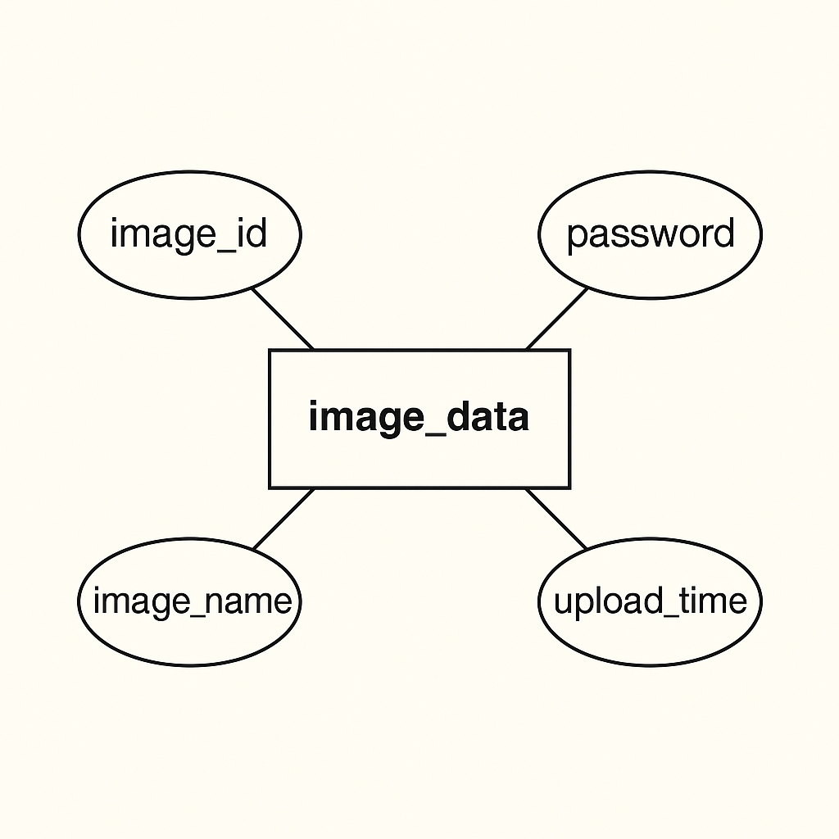

**Schema Design and Table Structure**

The project uses a single table in the database table called image_data. This table is designed to store minimal but essential information about the encrypted images. It includes three fields: image_id, image_name, and password. The image_id is a unique identifier (UUID) generated for each image, allowing it to be retrieved accurately. The image_name stores the filename of the uploaded image, and the password stores the user-defined password required to decrypt the message embedded in the image.

Here’s the SQL schema used to create this table:

CREATE TABLE image_data (

image_id VARCHAR(255) PRIMARY KEY,

image_name VARCHAR(255),

password VARCHAR(255)

);

The below image shows description of the table that has been created:

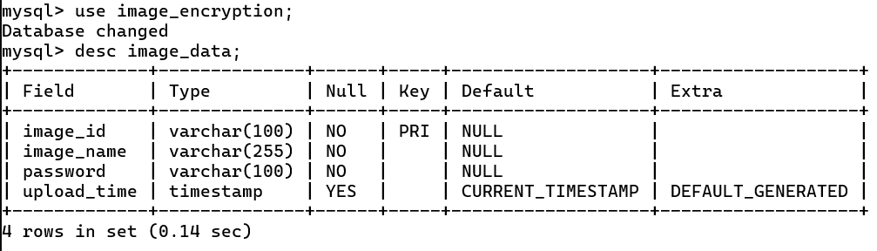

This simple schema effectively supports the functionality of the project by storing the minimal information needed for authentication and access control.

Here is the snapshot of the data that have been stored at a particular time of usage:

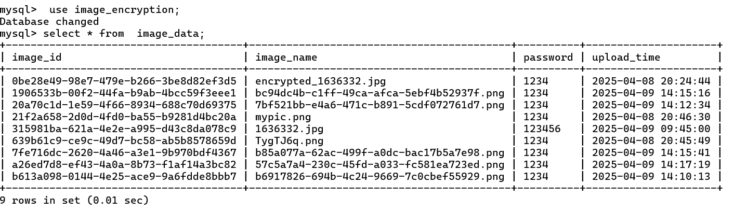

**7.1 UML Diagrams**

**Class Diagram:**

A **class diagram** is a type of Unified Modelling Language (UML) diagram used in software engineering to visually represent the structure and relationships of classes within a system. It is a fundamental tool in object-oriented design, providing a high-level overview of a system’s design and helping to communicate and document the structure of the software.

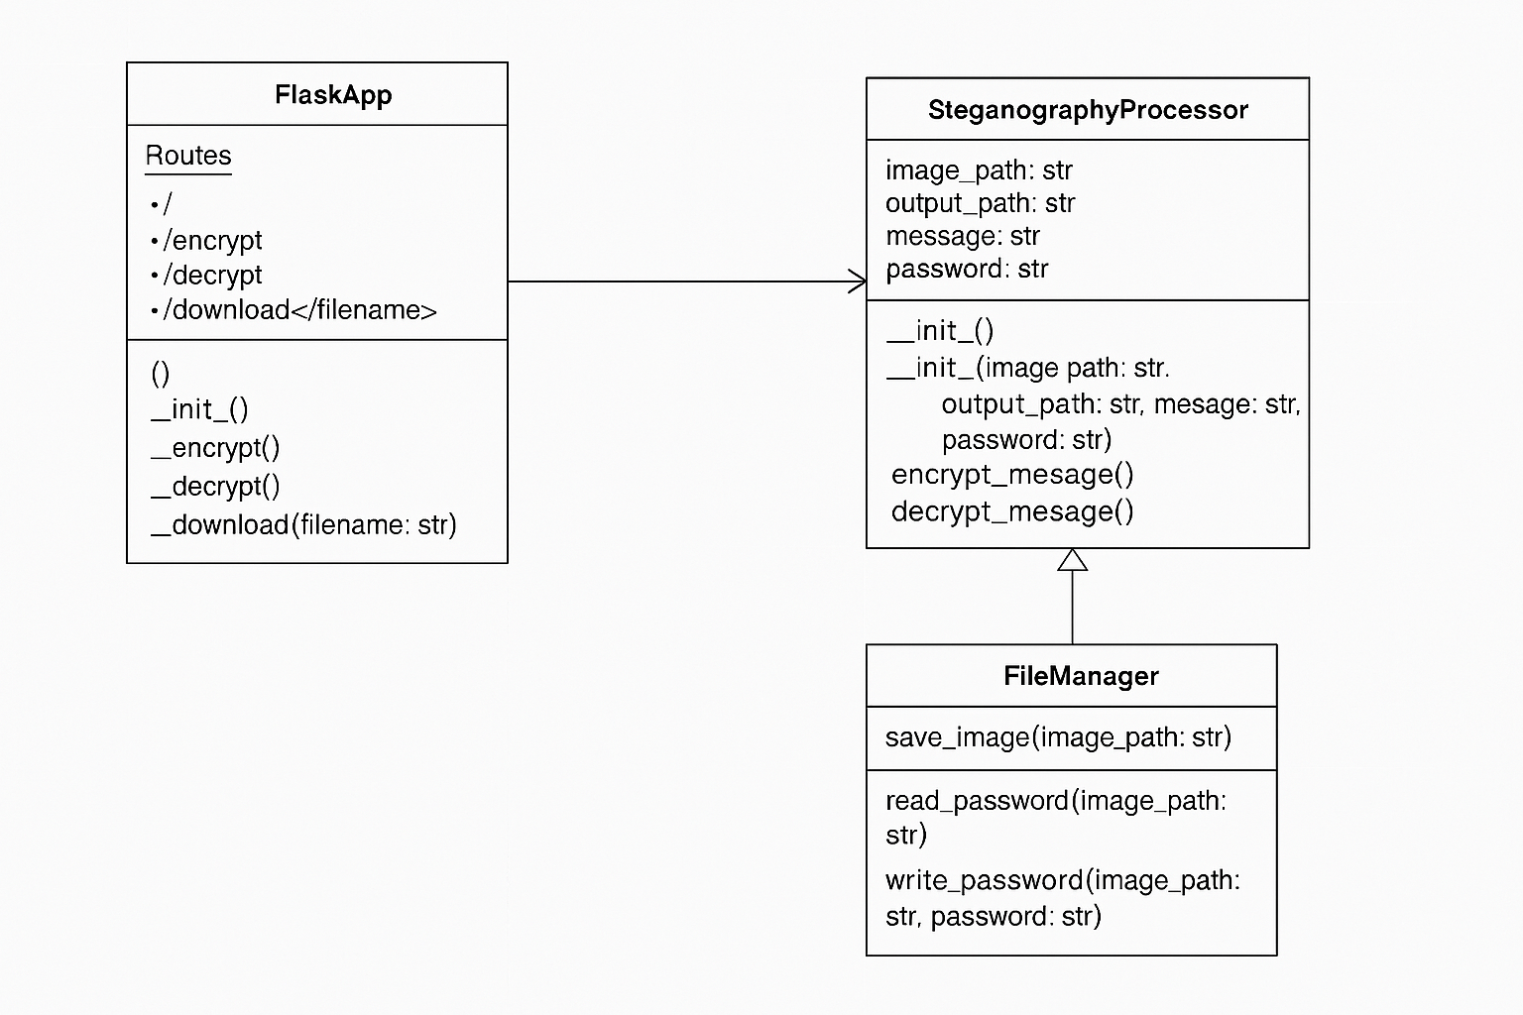

A class diagram in the context of your Flask-based steganography project visually represents the static structure of your system by illustrating the key classes, their attributes, methods, and relationships. The primary class is Flask App, which manages the web routes and user interactions, such as handling encryption and decryption requests through the encrypt() and decrypt() methods. It interacts closely with the Image Processor class, which contains methods like encrypt_message() and decrypt_message(), responsible for embedding and extracting the secret message within an image using OpenCV.

Another essential class is File Handler, which deals with operations such as saving uploaded files and storing or retrieving the password used for decryption. These classes work together to ful fill the user’s request when an image and message are uploaded via the web interface. The user acts as an external actor in the system, initiating actions that trigger method calls within these classes. This diagram helps developers understand how the system is structured, how data flows between components, and how each part of the application contributes to the overall functionality.

**Composite Structure:**

A **composite structure diagram** is a **UML structural diagram** that provides a **logical view of the internal structure** of a software system. It includes classes, interfaces, packages, and their relationships, showing how they interact and collaborate within the system.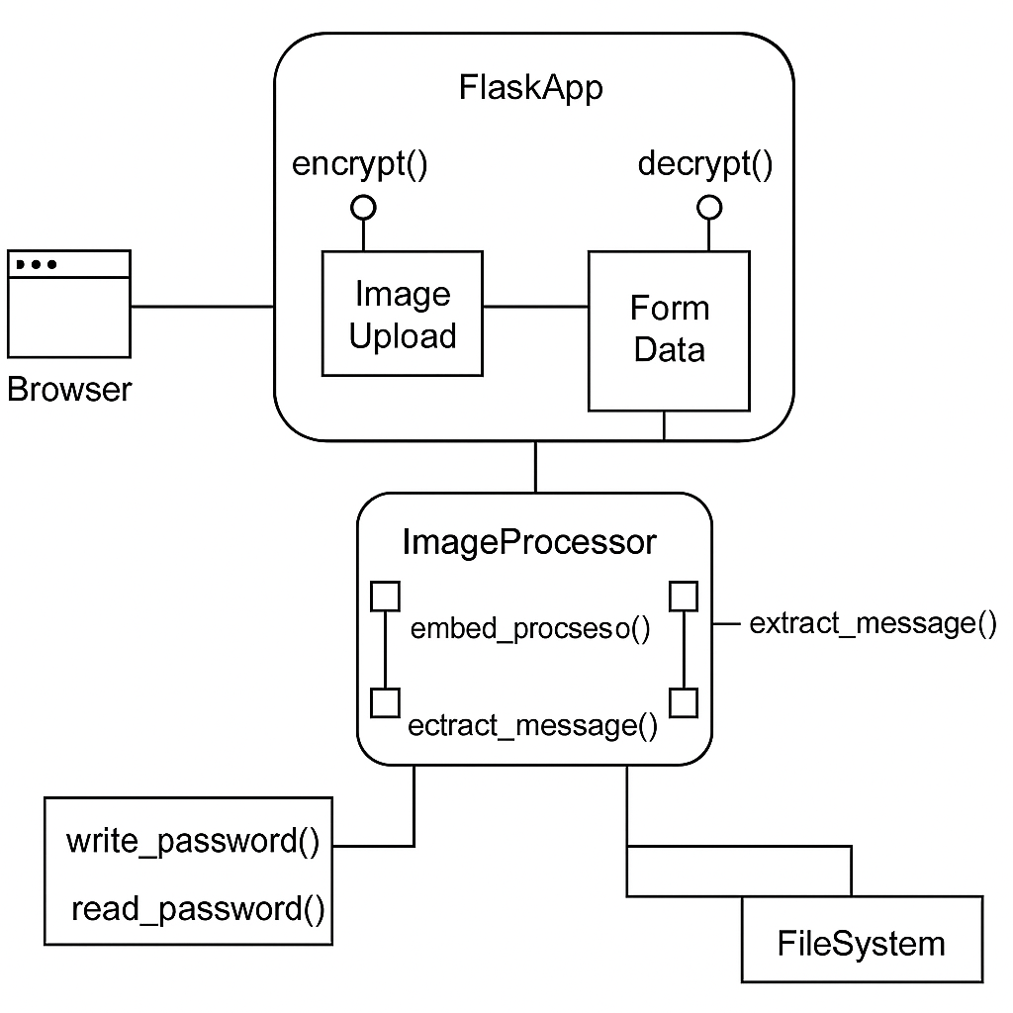

A composite structure diagram represents the internal structure of a class and how its parts collaborate to achieve the class’s behaviour. In the context of your Flask-based steganography project, a composite structure diagram would show how the main Flask App class is composed of and interacts with internal components like Image Processor and File Handler. It reflects how these internal parts (also called roles or ports) communicate with each other and with the outside environment. For example, within Flask App, the route handlers for encryption and decryption rely on internal communication with the encrypt_message and decrypt_message functions from Image Processor, and use File Handler to manage file operations like saving images and reading the password file.

The diagram also captures how data (like images and messages) flows through the system—from the user’s input, through Flask

App’s logic, and into the processing and storage components—ultimately resulting in an output that the user receives. This type of diagram is particularly useful when you want to dive deeper into the implementation details of a complex class and understand how its internal elements collaborate at runtime.

**Object Diagram:**

Object diagrams are a visual representation in UML (Unified Modelling Language) that illustrates the instances of classes and their relationships within a system at a specific point in time. They display objects, their attributes, and the links between them, providing a snapshot of the system’s structure during execution.

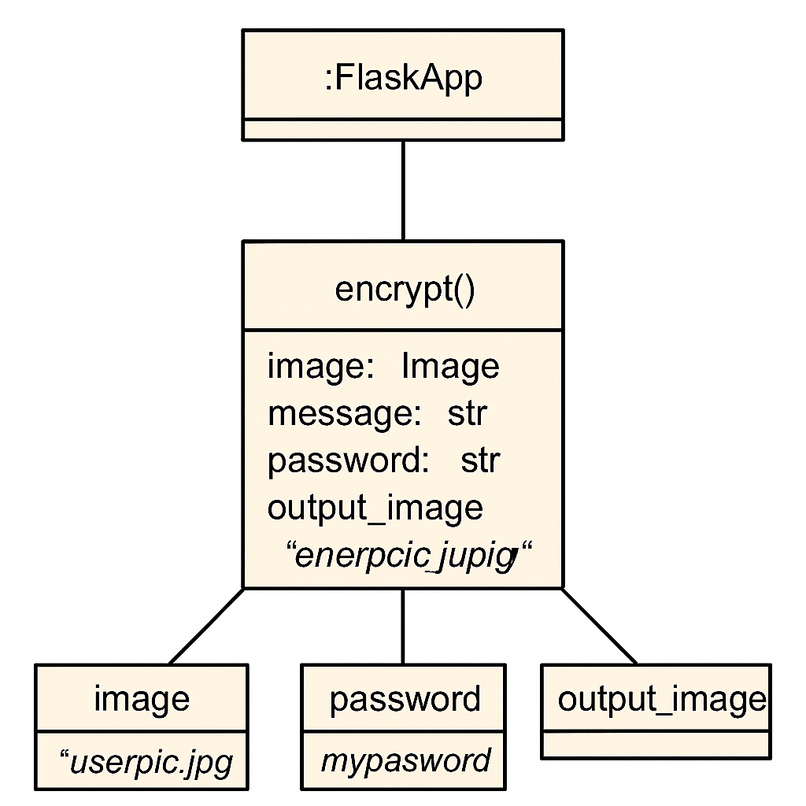

An object diagram provides a snapshot of the system at a particular moment in time by showing instances of classes (i.e., objects) and their relationships. In the context of your Flask-based steganography project, an object diagram could depict the system's state when a user has uploaded an image and submitted a message for encryption. For example, you might have an object of the Flask App class managing the current request, an Image Processor object holding the image data and message, and a File Handler object referencing the uploaded file and the associated password. These objects interact with each other—Flask App calls methods on Image Processor to process the image and on File Handler to save the output and password. The diagram would also show specific attribute values at that moment, such as the filename of the uploaded image or the actual text message being encrypted. This visualization helps in understanding how instances of classes behave and relate during the execution of a specific use case, making it a valuable tool for debugging or documentation.

**Activity Diagram:**

An activity diagram is a type of UML behavior diagram that visually represents the flow of actions or processes within a system. It illustrates parallel activities, decisions, and conditions, making it useful for system analysis and design.

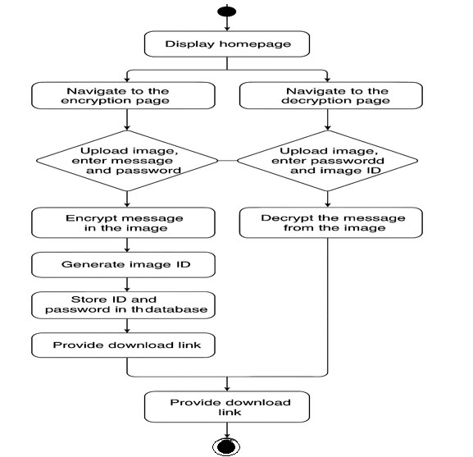

An activity diagram represents the dynamic behavior and workflow of a system by illustrating the sequence of activities or actions that take place during a particular process. In your Flask-based steganography project, an activity diagram can effectively depict the flow of operations during both encryption and decryption. For the encryption process, the diagram would start with the user uploading an image and entering a secret message along with a password. It then shows the system validating the input, saving the uploaded image, calling the encryption function to embed the message into the image, saving the encrypted image and password, and finally displaying a success message and providing a download option.

For the decryption process, the activity diagram would capture the steps beginning from uploading the encrypted image and entering the password, validating the password, calling the decryption function, extracting the message, and displaying the result to the user. Each step is represented as an action node, and decisions like password correctness are shown as decision branches. This diagram helps visualize the sequential flow of control and is particularly useful for understanding how user inputs are processed and how the system responds at each stage.

**Component Diagram:**

A Component Diagram is a type of structural diagram in the Unified Modeling Language (UML) that visualizes the organization and interrelationships of the components within a system. These diagrams are essential tools in software engineering, providing a visual representation of a system’s structure by showcasing its various components and their interactions.

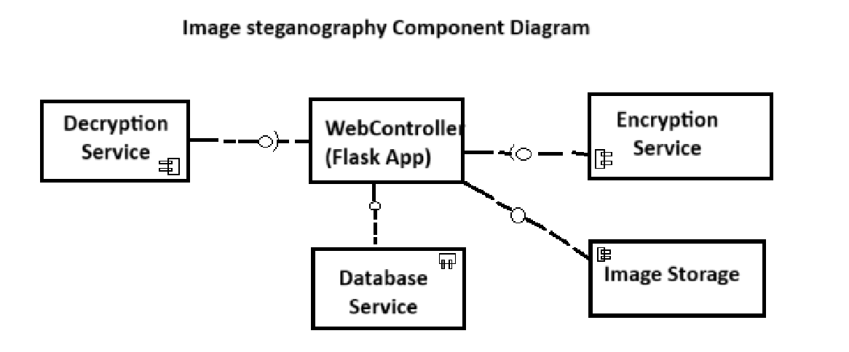

A component diagram is a type of structural UML (Unified Modeling Language) diagram that visually represents the components of a software system and how they interact with each other. It provides a high-level view of the software's physical structure by showcasing software components (such as modules, classes, functions, or subsystems), their interfaces, and the dependencies between them. Each component is depicted as a rectangular box with lollipop-style interface symbols, and connectors indicate the communication or usage relationships among them.

In the context of a Flask-based steganography project, a component diagram helps illustrate how different modules—like the Flask application, image processing functions (using OpenCV), file handling utilities, HTML templates, and the static upload directory—collaborate to achieve the encryption and decryption functionality. The user interacts with the Flask application through a web interface, which in turn depends on various components to process images, store passwords, and manage file uploads. This diagram helps in understanding the modular organization of the application, promoting better maintenance, scalability, and clarity in design documentation.

**Package Diagram:**

A package diagram is a type of structural diagram in UML (Unified Modeling Language) that organizes and groups related classes and components into packages. It visually represents the dependencies and relationships between these packages, helping to illustrate how different parts of a system interact with each other.

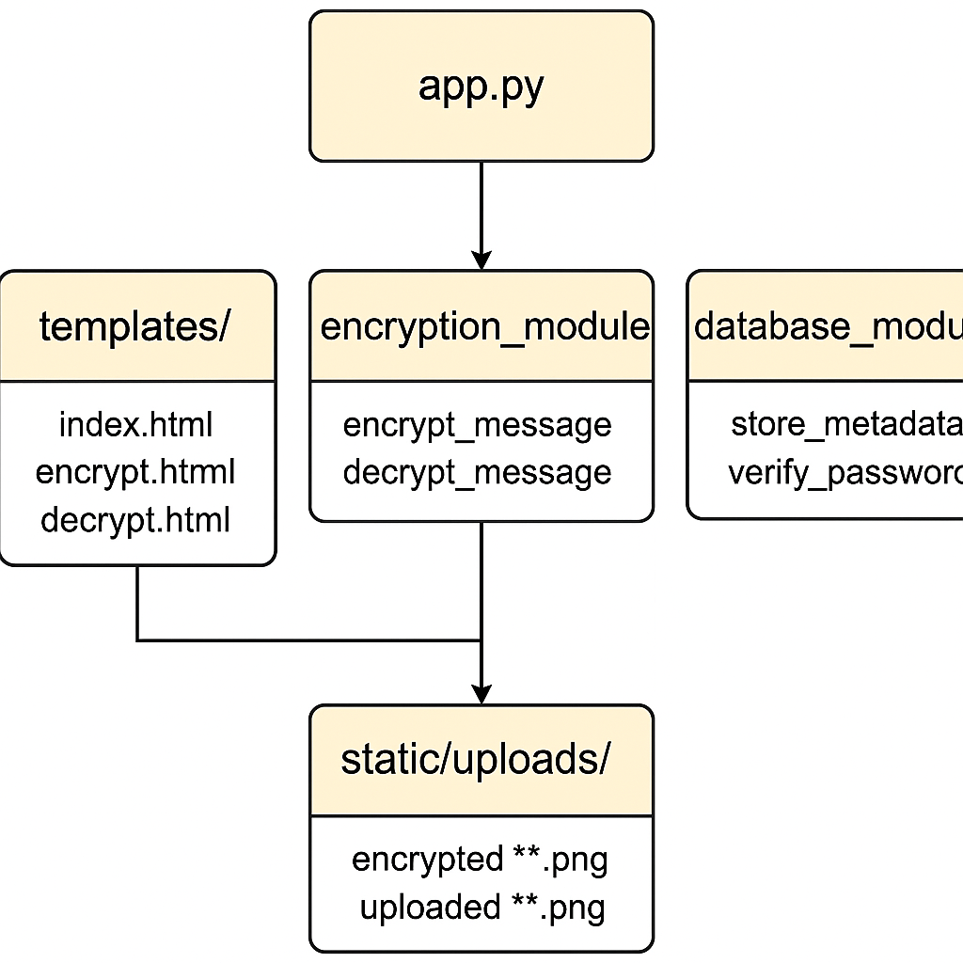

A **package diagram** in the context of your Flask-based steganography project helps organize the system into logical groupings, or "packages," to illustrate how different components interact with each other. In this diagram, key packages could include the **FlaskApp package**, which contains the core web application components, such as route handlers for encryption and decryption, app configurations, and setup files. It manages user requests and coordinates with other packages to perform encryption and decryption operations.

The **ImageProcessing package** holds the logic for embedding and extracting hidden messages from images using techniques like OpenCV. It includes functions like encrypt_message and decrypt_message that manipulate pixel data to embed or retrieve hidden messages. This package is crucial for the core functionality of the steganography system, ensuring that the image data is processed correctly for encryption and decryption.

The **FileHandling package** is responsible for managing file operations, such as saving uploaded images, storing encrypted images, and handling password files. It interacts with both the **FlaskApp** and **ImageProcessing** packages, ensuring that the necessary files are saved and retrieved for the encryption and decryption processes. It ensures the smooth handling of user files within the system.

The **UserInterface package** consists of the web front-end, including HTML templates, CSS, and JavaScript, allowing users to interact with the application, upload images, input messages, and view results. Finally, the **Security package** could include components related to encryption and decryption security, ensuring that passwords are correctly applied to protect hidden messages. The diagram shows the relationships and dependencies between these packages, making it easier to understand how the system’s components are organized and how they interact, ultimately promoting better maintenance and scalability.

**State Diagram:**

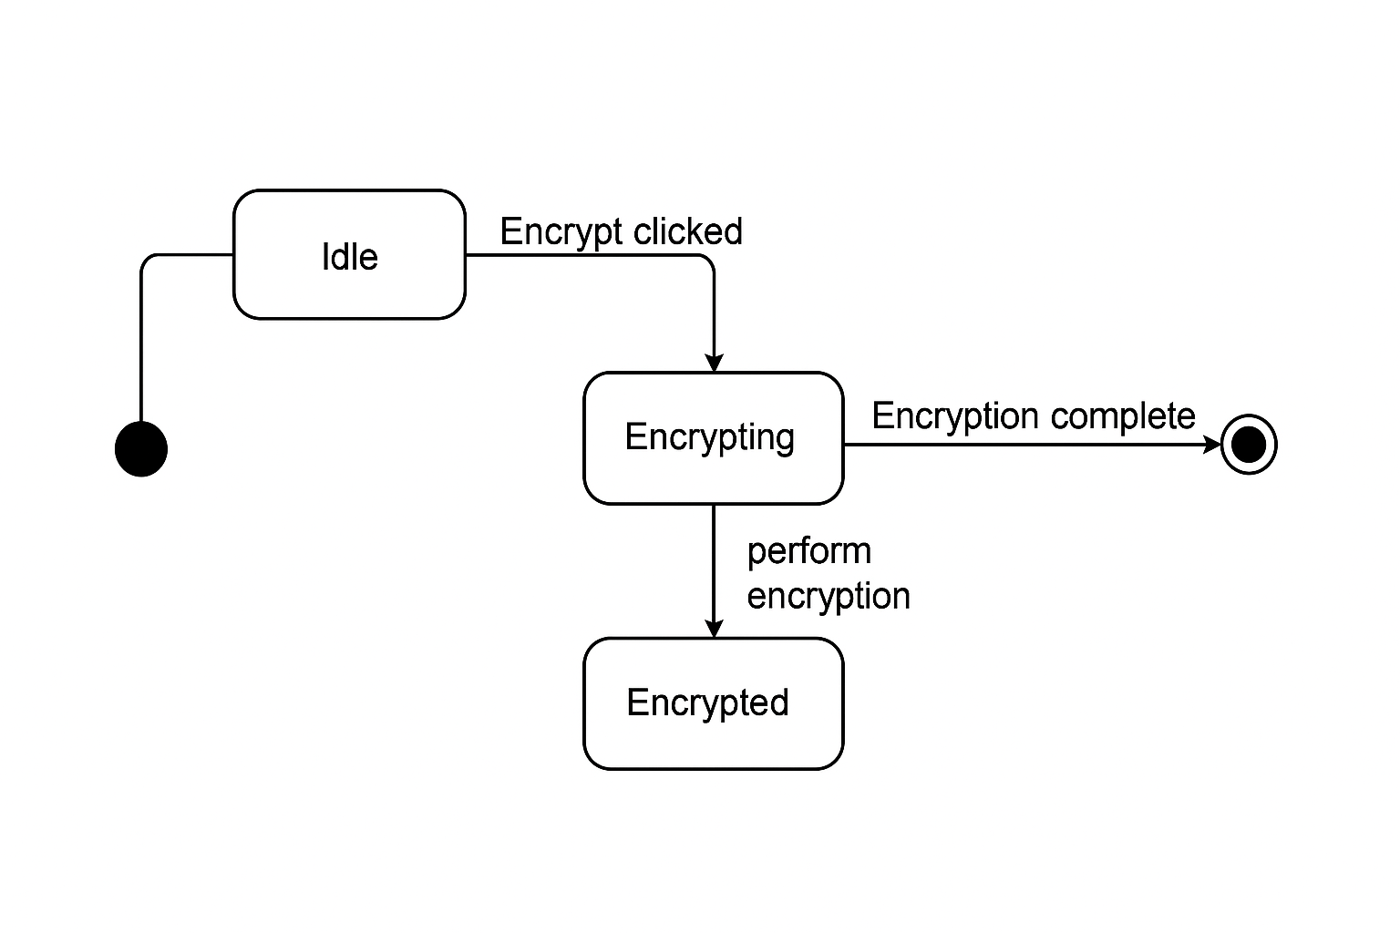

A state diagram in UML represents the different states an object or system can be in and how it transitions between those states based on events or actions. In the context of your Flask-based steganography project, the state diagram visually maps the flow of operations from

the moment a user enters the application to the completion of either encryption or decryption. The process begins at the Start state, where the user chooses to either encrypt or decrypt. If encryption is selected, the system moves through states such as Image Upload, Message Input, and Password Entry. Once all inputs are provided, the system transitions to the Encrypting Image state where the message is embedded into the image using OpenCV. After successful encryption, the system enters the Encryption Complete state and allows the user to download the encrypted image, eventually reaching the End state. On the other hand, if the user selects decryption, the flow begins with uploading the encrypted image, entering the decryption password, and then entering the Decrypting Message state where the system attempts to extract the hidden message. If successful, the system displays the decrypted message and transitions to the End state. The state diagram effectively captures this dynamic behavior, showing how the application responds to different user inputs and moves between functional states during the steganographic process.

**Use Case Diagram:**

A Use Case Diagram in Unified Modeling Language (UML) is a visual representation that illustrates the interactions between users (actors) and a system. It captures the functional requirements of a system, showing how different users engage with various use cases, or specific functionalities, within the system. 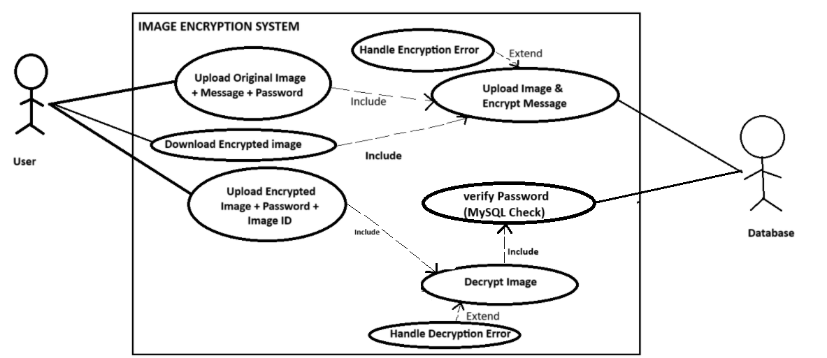

The package diagram of your Flask-based steganography project represents the modular structure and organization of your application. It visually breaks down the system into separate packages, each containing related components and functionalities. For example, the **FlaskApp package** serves as the main interface, handling routing and user interaction through endpoints like /encrypt and /decrypt. It is responsible for coordinating user requests and managing the overall workflow of the application.

The **ImageProcessing package** contains core logic for embedding and extracting messages from images, utilizing functions like encrypt_message and decrypt_message. This package is crucial for the core functionality of the system, as it manages the steganography techniques, such as pixel manipulation, to securely embed or retrieve the hidden messages.

**FileHandling** manages reading and writing to the filesystem, especially for handling uploaded files and storing the encryption password securely. It ensures smooth operations when interacting with the system's file storage, making sure that images and passwords are appropriately handled during both the encryption and decryption processes.

Additionally, the **Templates package** includes HTML templates such as encrypt.html, decrypt.html, and index.html that define the frontend views users interact with, while the **StaticFiles package** contains folders like /static/uploads/ used to store and serve user-uploaded and encrypted images. Arrows in the diagram represent dependencies, showing how the FlaskApp relies on the other packages to perform encryption and decryption workflows. This diagram helps developers understand the separation of concerns and the interaction between different modules in the system.

**Sequence Diagram:**

A sequence diagram is a Unified Modeling Language (UML) diagram that illustrates the sequence of messages between objects in an interaction. It shows how objects in a system interact with each other and the order in which these interactions take place. Sequence diagrams are used to design, document, and validate the architecture, interface, and logic of systems by describing the sequence of actions that need to be performed to complete a task.

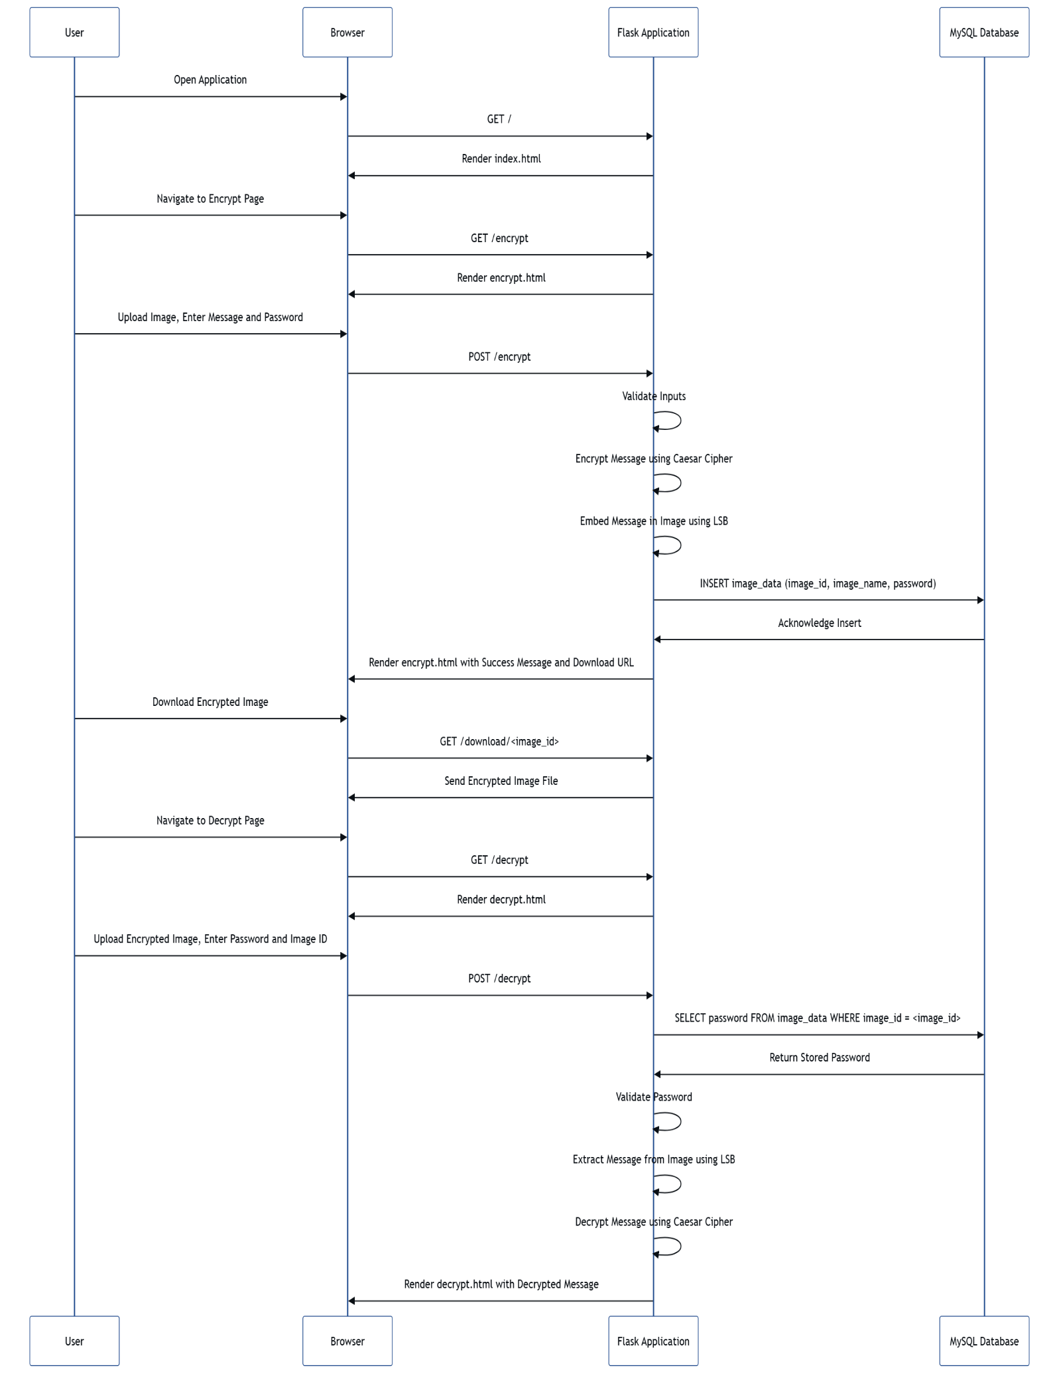

A package diagram in UML is used to visually represent the organization and grouping of various elements within a system into packages or modules. In the context of your Flask-based steganography project, the package diagram illustrates how the application is structured into different logical units, making it easier to understand, manage, and maintain. The central package is the FlaskApp, which acts as the controller that handles routing and user interactions, directing requests to appropriate functionalities like encryption and decryption. The ImageProcessing package contains the core logic responsible for embedding and extracting secret messages within image files using OpenCV. Another essential package is FileHandling, which manages reading from and writing to the file system—especially for saving uploaded images and storing passwords used for authentication. Additionally, the Templates package includes the HTML files (encrypt.html, decrypt.html, and index.html) that define the visual user interface, while the StaticFiles package contains resources like the uploads directory where encrypted and decrypted images are stored. Dependencies are shown through arrows that indicate which packages rely on others; for example, FlaskApp depends on both ImageProcessing and FileHandling to complete its tasks. Overall, the package diagram provides a high-level overview of how different components are grouped and interact in your steganography system, promoting modular design and clear separation of responsibilities.

**Collaboration Diagram:**

**collaboration diagram** (also called a communication diagram) illustrates how components (like the user, web interface, backend logic, and database) interact with one another to complete the main features of your **image encryption and decryption Flask application**.

**1. User Interaction**

The process starts with the **user**, who can either encrypt or decrypt an image. The user accesses the application through a web browser and interacts with it by uploading an image and providing required input such as a secret message and password (for encryption), or an image ID and password (for decryption).

**2. Flask Web Interface (Routes)**

When the user visits the encryption or decryption page and submits the form, the **Flask web interface** handles the request. It processes the user’s inputs through specific routes like /encrypt and /decrypt. These routes collect the form data and uploaded files, and then pass them to the backend logic for further processing.

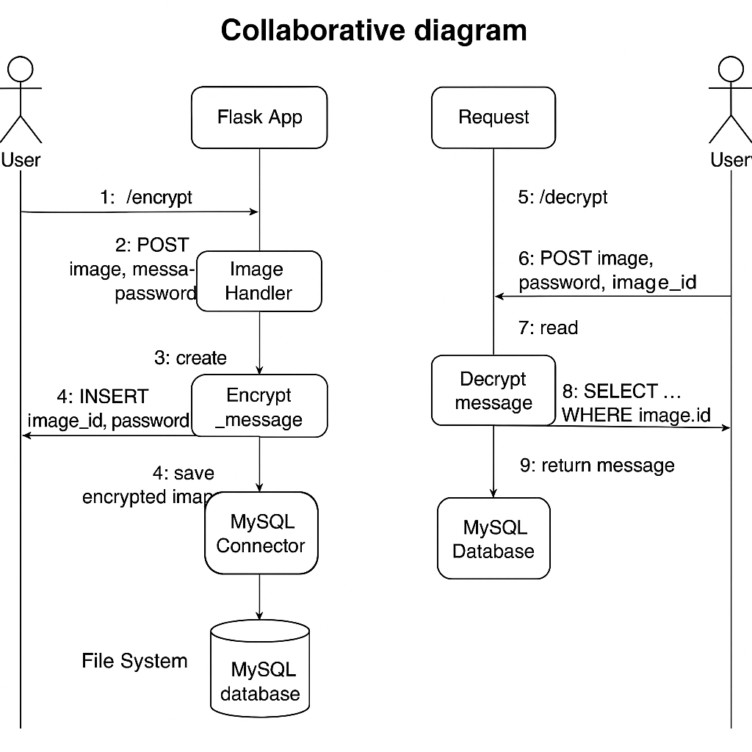

**3. Encryption Logic**

During encryption, the route calls the encrypt_message() function. This function uses OpenCV to read the uploaded image and embed the message into the image pixels. The modified image is then saved in the **static/uploads** folder.

**4. Database Interaction (MySQL)**

Once the message is successfully embedded in the image, the application generates a unique **image ID** using Python’s uuid module. This ID, along with the encrypted image filename and the password provided by the user, is saved in a **MySQL database** for later reference during decryption.

**5. Encryption Result**

After encryption, the user is shown a confirmation message on the frontend along with the **image ID** and a download link for the encrypted image.

**6. Decryption Logic**

During decryption, the user uploads the encrypted image and provides the associated image ID and password. The application checks whether the image ID exists in the database and verifies the password. If the password is correct, the decrypt_message() function extracts the embedded message from the image.

**7. Decryption Result**

Finally, the application returns the hidden message back to the user. If the password or image ID is incorrect, it displays an error message like **"YOU ARE NOT AUTHORIZED!"**

**Deployment Diagram**

A deployment diagram visualizes how the components of the system are deployed across physical or virtual hardware. Below is the deployment diagram for the Flask-based LSB Steganography Web Application, showing where each component runs and how they The image encryption and decryption system is a web-based application built using Flask (a Python microframework). It allows users to upload images, hide secret messages using steganography, and retrieve those messages later using a password-based authentication communicate.

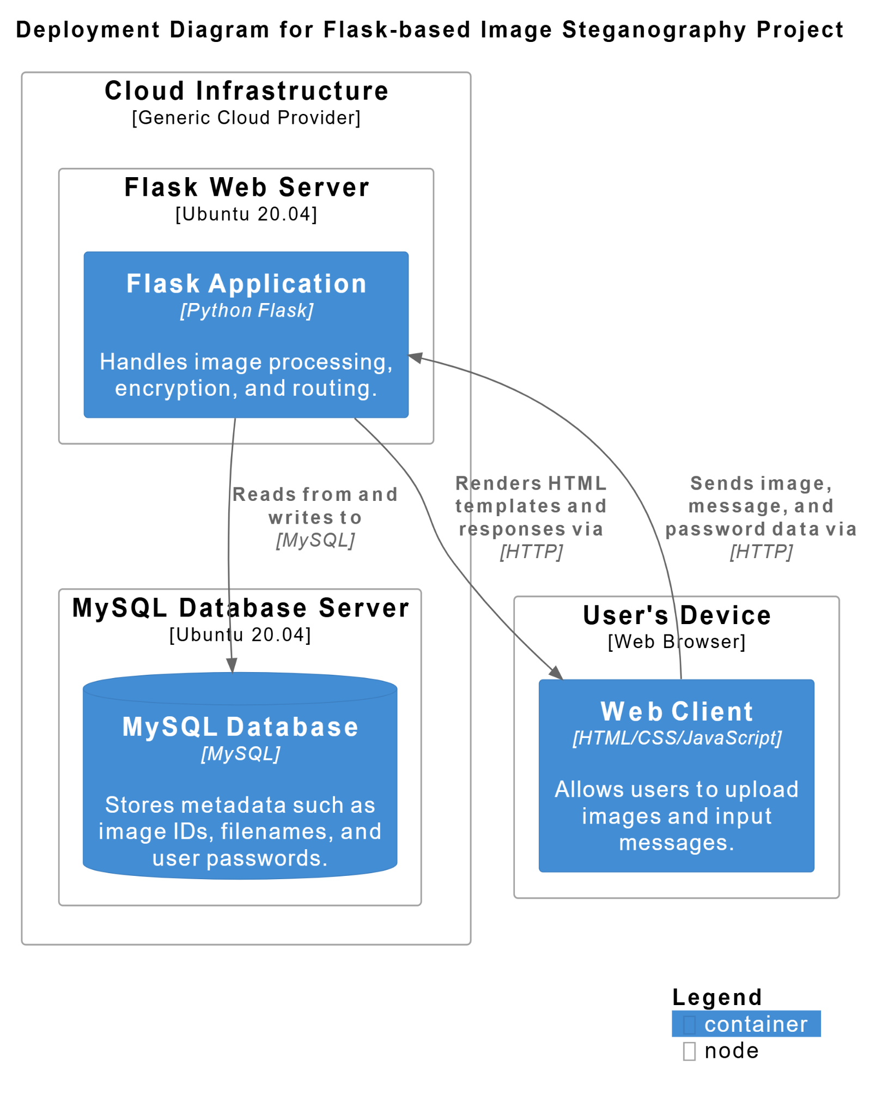

**1.1 Web Browser (Client Interface)**

This is the user-facing part of the system, typically accessed via a web browser. Users, whether admins or general users, interact with the application by uploading images, entering messages, setting passwords, and downloading the encrypted images. The browser sends requests (HTTP GET or POST) to the backend server and receives responses like images or success messages.

**1.2 Flask Web Server (Backend Logic)**

At the core of the application lies a Flask server, hosted and executed as app.py. This script defines several routes/endpoints:

* / – The homepage where users can navigate to encryption or decryption.
* /encrypt – Accepts image, message, and password; processes encryption.
* /decrypt – Accepts an encrypted image and password to extract the message.
* /download/<id> – Allows users to download the image encrypted earlier.

The Flask server also manages temporary storage of image data and invokes the actual image processing logic.

**1.3 Steganography Logic**

Embedded within the backend are two main functions:

* encrypt_message() – Hides a message inside the pixels of the image using the Least Significant Bit (LSB) method.
* decrypt_message() – Retrieves the hidden message from the image using the reverse of the above logic.

This layer is the core of the project’s functionality, abstracting the image encoding and decoding algorithms from the user.

**1.4 Pillow & NumPy (Image Processing)**

To handle image manipulation, the application uses:

* **Pillow (PIL)**: A Python imaging library that opens, reads, and saves images in different formats.
* **NumPy**: A numerical computing library that helps process image data in matrix form, allowing easy access and modification of pixel bits for steganography.

**1.5 MySQL Database (Metadata Storage)**

To enhance security and persistence, a MySQL database is used. It contains a table (image_data) in the image_encryption database. This table stores:

* A unique identifier for each image (image_id)
* The original image name
* The password set by the user during encryption

During decryption, the password entered is cross-verified with what's stored in this database to ensure authorized access to the hidden message.

**⚙️ 2. Installation and Setup**

To get this application running locally or on a server, follow these setup steps:

**2.1 Python & pip Installation**

Ensure Python (preferably version 3.7 or above) and pip (Python's package installer) are installed on your system. You can check by running:

python --version

pip –version

**2.2 Project Environment Setup**

Create a virtual environment for isolated package management:

python -m venv venv

Activate the environment:

* On **Windows**: venv\Scripts\activate
* On **Linux/macOS**: source venv/bin/activate

**2.3 Install Required Python Libraries**

Install the necessary libraries for backend processing:

pip install flask pillow numpy mysql-connector-python

These include:

* **Flask** for web routing.
* **Pillow** for image loading/saving.
* **NumPy** for efficient pixel manipulation.
* **mysql-connector-python** for connecting with the MySQL database.

**2.4 MySQL Database Configuration**

1. Launch MySQL and create the database:

CREATE DATABASE image_encryption;

1. Switch to the new database:

USE image_encryption;

1. Create the table to store image metadata:

CREATE TABLE image_data (

image_id VARCHAR(255) PRIMARY KEY,

image_name VARCHAR(255),

password VARCHAR(255)

);

1. In your app.py, configure the database connection with your credentials (host, user, password, db name).

**2.5 Running the Flask Application**

Finally, launch the Flask server:

bash

Then, open your browser and go to http://127.0.0.1:5000 to use the application. From here, you can test encryption and decryption functionalities.

**CHAPTER 8**

**SYSTEM TESTING**

The aim of the system testing process was to determine all defects in our project. The program was subjected to a set of test inputs and various observations were made and based on these observations it will be decided whether the program behaves as expected or not. Our Project went through two levels of testing.

1. Unit testing

2. Integration testing

**UNIT TESTING**

**Overview**

This Python code uses the unittest framework to test the functionality of steganography functions, specifically encrypt_message and decrypt_message. Steganography is the practice of concealing a message within another, non-secret, medium. In this case, the medium is an image.

The tests cover various scenarios, including:

* Basic encryption and decryption: Testing if the core functions work as expected.
* Handling invalid input: Checking how the functions handle incorrect data, like invalid images or empty messages.
* Edge cases: Ensuring the functions behave correctly when the message is too large for the image.
* Correct password for decryption: Verifying that the decryption process works correctly with the right password.

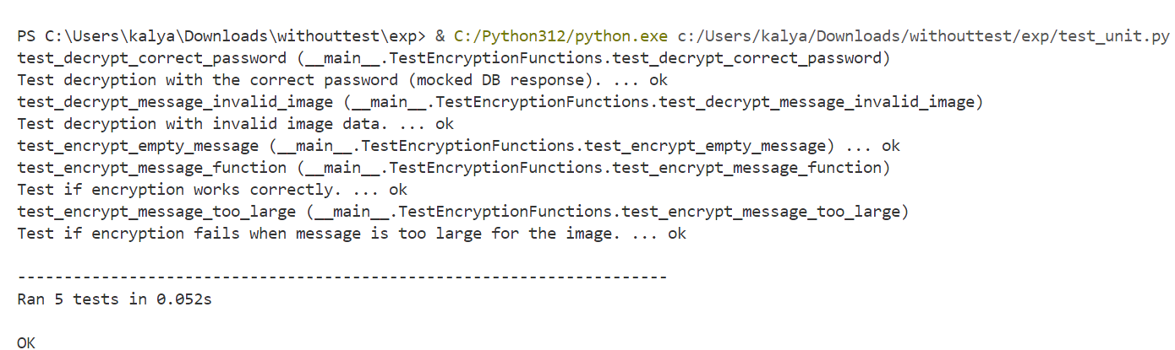

**Detailed Explanation of Each Test**

**INTEGRATION TESTING**

**Overview**

This Python code uses the unittest framework to perform integration tests on a Flask application named app. The application appears to provide functionality for encrypting and decrypting messages within images (steganography).

Integration tests verify the interaction between different parts of the application, ensuring they work together as expected. In this case, the tests check if the routes of the Flask application are functioning correctly.

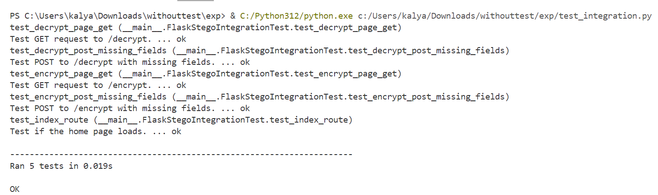

**Code Breakdown**

1. Import Statements:
   * import unittest: Imports the unittest framework for writing tests.
   * from app import app: Imports the Flask application object named app from the app.py file. This is crucial for accessing the application's routes and functionality within the tests.
2. FlaskStegoIntegrationTest Class:
   * This class defines the test cases for the Flask application. It inherits from unittest.TestCase, providing the structure and methods for creating and running tests.
3. setUp(self) Method:
   * This method is part of the unittest framework and is executed before each test method.
   * It configures the Flask application for testing:
     + self.app = app.test_client(): Creates a test client for the Flask application. This client allows you to simulate making requests to the application without running a server.
     + self.app.testing = True: Sets the application's testing mode to True. This is important for enabling features like catching exceptions and getting more detailed error messages during testing.
4. Test Methods:
   * Each method in the class that starts with test_ is a test case. These methods define specific scenarios to be tested.
   * test_index_route(self):
     + Tests the home page (/) of the application.
     + response = self.app.get('/'): Simulates a GET request to the home page.
     + self.assertEqual(response.status_code, 200): Asserts that the response status code is 200 (OK), indicating that the page loaded successfully.
     + self.assertIn(b'Encrypt', response.data): Asserts that the response data (the HTML content of the page) contains the text "Encrypt", which suggests that the home page has the encrypt functionality.
   * test_encrypt_page_get(self):
     + Tests the /encrypt page with a GET request.
     + Similar to test_index_route, it checks for a 200 status code and the presence of "Encrypt" in the response data.
   * test_encrypt_post_missing_fields(self):
     + Tests the /encrypt page with a POST request but with missing form data.
     + response = self.app.post('/encrypt', data={}): Simulates a POST request to /encrypt with an empty dictionary as the data (meaning no form fields are sent).
     + self.assertIn(b'All fields are required.', response.data): Asserts that the response data contains the error message "All fields are required.", indicating that the application correctly validates the form data.
   * test_decrypt_page_get(self):
     + Tests the /decrypt page with a GET request.
     + Checks for a 200 status code and the presence of "Decrypt" in the response.
   * test_decrypt_post_missing_fields(self):
     + Tests the /decrypt page with a POST request and missing form data.
     + response = self.app.post('/decrypt', data={}): Simulates a POST request to /decrypt with no data.
     + self.assertEqual(response.status_code, 200): Asserts that the response status code is 200 (OK).
     + self.assertIn(b'All fields are required.', response.data): Asserts the response contains "All fields are required."
5. if __name__ == '__main__': Block:
   * This is a standard Python construct that ensures the code inside this block is executed only when the script is run directly (not when imported as a module).
   * unittest.main(verbosity=2): Runs the unit tests with a verbosity level of 2, which provides more detailed output about the test results.

**CHAPTER 9**

**CONCLUSION AND FUTURE SCOPE OF PROJECT**

**Project Success**  
This steganography project successfully implements a secure message-hiding system within digital images using Flask and OpenCV. The application provides an end-to-end solution for covert communication through an intuitive web interface.

* **Core Achievements**The system effectively demonstrates LSB (Least Significant Bit) steganography techniques while maintaining image integrity. Password protection and MySQL database integration ensure secure data handling and access control.
* **Technical Validation**  
  Comprehensive unit and integration testing confirms the reliability of both encryption/decryption workflows and system components. The project serves as a functional proof-of-concept for practical steganography applications.

**Future Scope**

* **Security Enhancements**  
  Implementation of AES/RSA encryption would strengthen data protection. Multi-factor authentication and brute-force prevention mechanisms could further secure the decryption process.
* **Feature Expansion**  
  Support for additional media types (audio/video) and batch processing capabilities would increase versatility. Cloud storage integration would improve accessibility and user convenience.
* **Performance Optimization**Future work could focus on GPU acceleration and memory optimization to handle larger files efficiently. Parallel processing implementation would significantly improve processing speeds.
* **Platform Expansion**  
  Development of mobile applications and browser extensions would make the technology more accessible across different devices and platforms.
* **AI Integration**  
  Incorporating neural networks could enable more sophisticated data hiding techniques and automated payload distribution across multiple carrier files.
* **Security Analysis**  
  Adding steganalysis capabilities would allow users to test their own images for hidden data, making the tool valuable for both offensive and defensive security purposes.

**Final Outlook**

This project establishes a strong foundation for digital steganography applications. With continued development focusing on security, performance, and accessibility, it has significant potential to evolve into a comprehensive privacy solution for various professional and personal use cases. The integration of advanced technologies like AI and cryptography could position it as a next-generation tool in secure digital communication.

**CHAPTER 10**

**SYSTEM SECURITY MEASURES**

1. **Password Protection for Decryption**

To safeguard the confidentiality of embedded messages, the application incorporates a password verification mechanism during the decryption process. When a user encrypts an image, they provide a password that is securely stored in the database alongside the image identifier. During decryption, the user must supply the correct password and image ID, which is cross-verified with the stored data. This ensures that only authorized users can retrieve the hidden message embedded within the image.

1. **Secure Data Storage and Database Access**

The MySQL database used to store image metadata and associated passwords is protected with authenticated access, ensuring that only the application and authorized administrators can interact with it. Sensitive fields such as passwords are stored as plain text in the current implementation, but for better security, these should ideally be hashed using secure algorithms like SHA-256. Access to the database server is restricted to prevent unauthorized direct connections and potential data breaches.

1. **Input Validation and File Handling**

User inputs, including uploaded image files, image IDs, and passwords, are validated on the server side to ensure they conform to expected formats and do not pose a threat to system integrity. Uploaded files are saved with a unique UUID-based filename, reducing the risk of overwriting existing files or allowing users to predict file names for unauthorized access. File types are restricted to image formats, and storage is confined to a dedicated uploads folder to minimize the attack surface.

1. **Protection Against Unauthorized File Access**

The application prevents unauthorized file access through the use of Flask’s send_from_directory method, which restricts file serving to a specific folder. This guards against path traversal vulnerabilities that could otherwise allow users to request arbitrary files on the server. Additionally, files not matching expected naming conventions or those not present in the uploads directory will return a 404 error, further limiting exposure.

1. **Error Handling and Information Disclosure**

All error messages returned to users are sanitized to avoid leaking internal information such as file paths, system variables, or SQL errors. Instead of showing raw exceptions, user-friendly messages are displayed while the actual errors can be logged internally for developers to analyze. This reduces the chance of giving attackers insight into how the system works.

1. **Future Recommendations: HTTPS and Environment Security**

While the development environment may use plain HTTP and default credentials, deploying the application in a production environment should include enabling HTTPS to encrypt data in transit. Server and database environments should be hardened using firewalls, secure permissions, and environment variables for credentials instead of hardcoding them. Regular backups and audit logs are also recommended for better incident response**.**

**CHAPTER 11**

**REFERENCES**

[1] Rituparna Halder, Susmit Sengupta, Sudipta Ghosh, Debashish Kundu, “A Secure Image Steganography Based On RSA Algorithm And Hash-LSB Technique”, IOSR-JCE, Volume 18, Issue 1, Ver. Iv Jan – Feb. 2016

[2] Mehdi Hussain And Mureed Hussain, "A Survey Of Image Steganography Techniques", International Journal Of Advanced Science And Technology, Vol. 54, May 2013

[3] Marwa E. Saleh, Abdelmgeid A. Aly, Fatma A. Omara, "Data Security Using Cryptography And Steganography Techniques", Ijacsa, Vol. 7, No. 6, 2016

[4] Sahil Lotlikar, Ashish Gupta, Jayesh Thorat, Sandhya Kadam, "Image Steganography And Cryptography Using Three Level Password Security", IJRASET, VOLUME 5 ISSUE Iv, APRIL 2017

[5] Ahmed Al-Shabby, Talal Alkharobi, "Cryptography And Steganography: New Approach", TNC, VOLUME 5, NO. 6, ISSN: 2054 -7420, Year: DECEMBER 2017

[6] Hayfaa Abdulzahra, Robiah Ahmad and Norliza Mohd Noor, "COMBINING CRYPTOGRAPHY AND STEGANOGRAPHY FOR DATA HIDING IN IMAGES", ISBN: 978-960-474-368-1

[7] Radha S. Phadte and Rachel Dhanaraj, “Enhanced Security with Steganography and Cryptography”, IOSR Journal of Computer Engineering, Year: 2017

[8] Mustafa Sabah Tah, Mohd Shafry Mohd Rahim, Sameer Abdul Sattar lafta, Mohammed Mahdi Hashim, Hassanain Mahdi Alzuabidi, "Combination of Steganography and Cryptography: A short Survey", IOP Conference Series: Materials Science and Engineering, Year: 2019

[9] Vishnu S Babu and Prof. Helen K J, “A Study on Combined Cryptography and Steganography”, International Journal of Research Studies in Computer Science and Engineering (IJRSCSE), Year: May 2015, Volume 2, Issue 5, PP 45-49

[10] Sharmin Sultana, Afrida Khanam, Md. Rashedul Islam, Adiba Mahjabin Nitu, Md.Palash Uddin, Masud Ibn Afjal and Md. Fazle Rabbi, "A Modified Filtering Approach of LSB Image SteganographyUsing Stream Builder along with AES Encryption”, Year: 2018, Volume 1, Issue 2

[11] Pashang Engineer, Priyanka A. Bansode, Shreya Vitthalrao Surnar, Prathmesh N. Gunjgur, “Secured Crypto Stegano Communication”, International Journal of Advanced Research in Computer and Communication Engineering, Vol. 8, Issue 4, April 2019

[12] Vipul Sharma and Madhusudan, “Two New Approaches for Image Steganography Using Cryptography”, Year: 2015

[13] Varsha1, Dr. Rajender Singh Chhillar2, "Data Hiding Using Steganography and Cryptography", International Journal of Computer Science and Mobile Computing, Vol. 4, Issue. 4, April 2015, pg.802 – 805

BASE paper : [IRJET-V7I5304.pdf](https://www.irjet.net/archives/V7/i5/IRJET-V7I5304.pdf)

<http://www.w3schools.com/html/html_intro.asp>

<http://www.Udemy.com/css/css_background.asp>

<http://www.w3schools.com/js/js_datatypes.asp>

[ChatGPT](https://chatgpt.com/)

[What is Steganography? | GeeksforGeeks](https://www.geeksforgeeks.org/what-is-steganography/)

[Flask Tutorial | GeeksforGeeks](https://www.geeksforgeeks.org/flask-tutorial/)

[OpenCV Tutorial in Python | GeeksforGeeks](https://www.geeksforgeeks.org/opencv-python-tutorial/)

[Connect MySQL database using MySQL-Connector Python | GeeksforGeeks](https://www.geeksforgeeks.org/connect-mysql-database-using-mysql-connector-python/)

[OpenCV Tutorial in Python | GeeksforGeeks](https://www.geeksforgeeks.org/opencv-python-tutorial/)

[Connect MySQL database using MySQL-Connector Python | GeeksforGeeks](https://www.geeksforgeeks.org/connect-mysql-database-using-mysql-connector-python/)

[Python Pillow Tutorial](https://www.tutorialspoint.com/python_pillow/index.htm)

